**ABSTRACT**

Greenhouse Environment Control System forms an important part of the agriculture and horticulture sectors in our country as they can be used to grow plants under controlled climatic conditions for optimum produce. Appropriate environmental conditions are necessary for optimum plant growth, improved crop yields, and efficient use of water and other resources. Main focus of this project is to design a simple, easy to use, micro-controller based circuit which monitor and record the values of temperature, humidity and pH level of the natural environment that are continuously modified and controlled.

The system has a pH sensor immersed in water which continuously measure the pH value and DHT 11 sensor senses the temperature and humidity level inside the room (greenhouse), both sensors sends the mandatory information to the microcontroller, the microcontroller in turn processes the input and then controls the motors and electronic equipments connected to it through relays. These motors are generally used to control the addition of nutrients and pH controlling elements. If the pH level goes low then acid is added while in the other case when the pH goes high above the pre-set value then base is added. Required amount of fertilizer is added on daily basis. If humidity level goes above the pre-set value then exhaust fan will be turned on still it comes to normal state, no change will happen if it goes below the pre-set value. If the temperature goes above pre-set value cooling fan will be turned on, if it goes below the pre-set value, heater will be turned on. The light will be turned on for 16 hours in a day. A real-time clock (RTC) is a computer clock (most often in the form of an integrated circuit) that keeps track of the current time.

**CONTENTS**

**CHAPTER PAGE NO.**

**ACKNOWLEDGEMENT…………………………………………………………………............ (I)**

**SYNOPSIS.………………………………………………………………………………………... (II)**

**LIST OF FIGURES………………………………………………………………………..……… (III)**

**LIST OF TABLES……………………………………………………………………….………... (IV)**

**1. INTRODUCTION…………………………………………………………...................... 1**

1.1 Overview 1

1.2 Literature Review 1

1.3 Existing System 3

1.4 Proposed System 4

1.5 Scope 4

1.6 Chapters Overview 4

**2. HYDROPONICS…........................................................................................……… 5**

2.1 Hydroponics 5

2.2 Types of Hydroponic System 6

2.3 EBB & Flow 6

2.4 Benefits of EBB & Flow 6

2.5 Downsides of EBB & Flow 7

2.6 Hydroponic Lettuce 7

**3. BLOCK DIAGRAM AND CIRCUIT DIAGRAM…..………………………….............. 9**

3.1 Block Diagram 9

3.2 Circuit Diagram 12

**4. HARDWARES USED………..………………………………………………………….. 14**

4.1 Microcontroller-PIC16F887 14

4.2 pH Sensor 18

4.3 Power Supply 18

4.4 LCD Display 19

4.5 Relay Module 21

4.6 Peristaltic Pump 23

4.7 DHT11 Sensor 24

4.8 Exhaust Fan 25

4.9 Cooling Fan 26

4.10 Heater 26

4.11 Grow Light 27

**5. SOFTWARE USED………………………………………………......................……… 29**

5.1 Procedure for Editing and Compiling 29

5.2 Procedure for Downloading the Code 33

**6. PROGRAM………………………………………………………………………………. 35**

**7. OUTPUT………….……………………………………………………………………… 50**

7.1 Hardware Module 50

7.2 Hardware Module before Turning on 51

7.3 Hardware Module after Turning on53

**CONCLUSIONS…………………………………………………………………………..……... 56**

**BIBLIOGRAPHY……………………………………………………………………………..….. 57**

**LIST OF FIGURES**

**FIGURE FIGURE NAME PAGE NO.**

1.1 Green House 1

1.2 NASA testing Hydroponics 3

2.1 Hydroponics vs Soil-for Hybrid tomato 5

2.2 EBB & Flow method 7

2.3 Hydroponics vs Soil Plants 8

2.4 Hydroponics Lettuce 8

3.1 Block Diagram 10

4.1 Pin Diagram of PIC16F887 16

4.2 pH Table 18

4.3 5v Power Supply 19

4.4 12v Power Supply 19

4.5 LCD Display 20

4.6 Relay Module 22

4.7 Pin Diagram of Relay 23

4.8 Peristaltic Pump 24

4.9 DHT11 Sensor 25

4.10 Exhaust Fan 25

4.11 Cooling Fan 26

4.12 Heater 27

4.13 Grow Light 28

5.1 Initialization window 29

5.2 Open Project Wizard Window 30

5.3 Project Wizard Window : Select Device 30

5.4 Project Wizard Window : Select Location 31

5.5 Project Wizard Window : Create a New Project 31

5.6 Project Wizard Window : Add the Existing File 32

5.7 Project Wizard Window : Project Summary 32

5.8 Programmer Option 33

5.9 Programmer Option : Select Programmer : PICkit2 33

5.10 Programmer Option : Connect 34

6.1 Hardware Module 50

6.2 Green House 50

6.3 LCD Before Process 51

6.4 pH Sensors Value Initially 51

6.5 Relays Turned Off 51

6.6 Grow Light is Off 52

6.7 Cooling Fan is Off 52

6.8 LCD Display After Process 53

6.9 pH Sensors Output 53

6.10 Relay Module After Turning On 53

6.11 Grow Light is On 54

6.12 Cooling Fan is On 54

6.13 Plant and The Supporting Cup 55

**LIST OF TABLES**

**TABLE TABLE NAME PAGE NO.**

2.1 Requirements of Hydroponics Lettuce 8

4.1 Register Description 16

4.2 PIC16F887 Features 17

4.3 Character LCD type 16x2 pin diagram 21

**CHAPTER 1**

**INTRODUCTION**

**1.1 OVERVIEW**

Technological developments today make the combination of science. Computer Science and Agriculture make use of each other. The aim of this project is to develop is to automate the greenhouse that uses the concept of hydroponics. A greenhouse (also called a glasshouse or hothouse) is a building where plants such as flowers and vegetables are grown. It usually has a glass or translucent plastic roof. Many greenhouses also have glass or plastic walls. Greenhouses warm up during the day via penetration of the sun's rays which heat the plants, soil and structure. This heat is given up gradually throughout the night. Figure1.1 shows clear diagram of Green House.

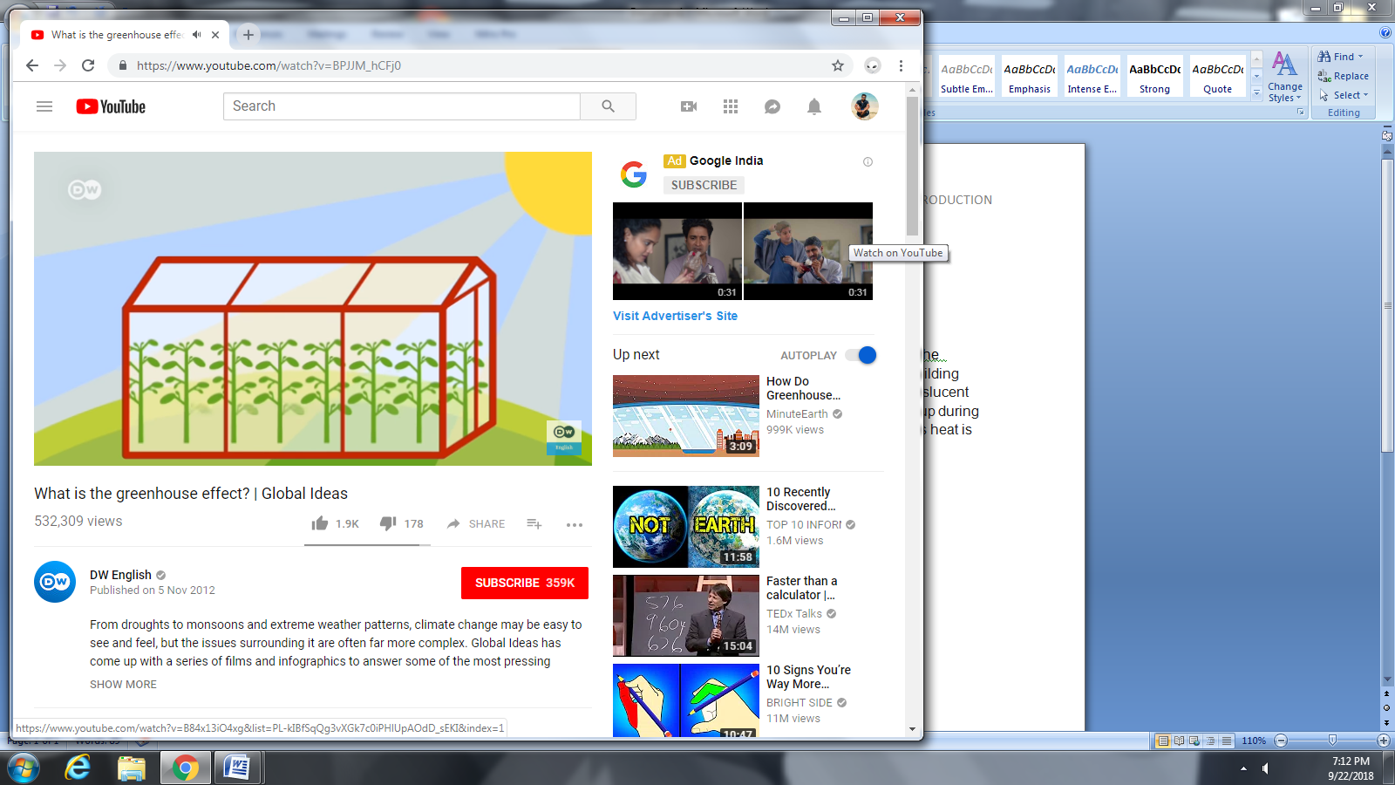

FIGURE 1.1 GREEN HOUSE

**1.2LITERATURE REVIEW**

**2nd International Conference On Computing and Applied Informatics 2017**

**Automated Hydroponics Nutrition Plants Systems**

This paper had developed a control tool for the flow of nutrients of hydroponic plants automatically using Arduino microcontroller and controlled by Smartphone. An ArduinoUno microcontroller to automatically control the flow of nutrient solution with logic if else. The microcontroller can also send data of fluid level (solution) and temperature around the plant to Smartphone android of the owner of the hydroponics plant.

**IJSTE - International Journal Of Science Technology & Engineering**

**Automation Of Hydroponic System**

Hydroponics is a technique to grow the plant without use of the soil. This paper presents an efficient hydroponic system which had automated to monitor plant living conditions and adjust plant pH and temperature to maintain optimal nutrient uptake by plant root systems. The microcontroller is used in the system and it will poll the sensors for information about the nutrient solution. If the solution is not within the range, the microcontroller will initiate the steps to correct the pH and temperature of solution.

**International Journal of Advanced Research in Electrical, Electronics and Instrumentation Engineering**

**Design and Implementation of Automatic Hydroponics System using ARM Processor**

This paper had a two electrode sensor for measuring water conductivity for the hydroponics system is presented. The sensor is designed to measure the conductivity of nutrient solution which is in the range of millisiemens (mS). These electrodes are used to regulate the nutrient in hydroponics solution according to the plant’s requirement. The automatic hydroponic system is based on low cost ARM processor that monitors and control the need of hydroponics plants. Automatic hydroponics system will boost the production by controlling the different parameters.

**Oulu University of Applied Sciences**

**The Design and Implementation of a Hydroponics Control System**

This thesis was born out of the idea to make hydroponic food growing easier and cheaper, hydroponics is essentially the growing of plants without the use of soil. The idea of it being open source is also in keeping with the general community feeling surrounded by the hydroponic movement. The objective of the thesis was to create a working hydroponic controller, which is cheap and simple enough to build. It will monitor and control the key environmental ingredients needed for successful hydroponic growing, chiefly the pH, EC, air and water levels. Visual alarms will be raised if these go outside of predefined ranges. The controller will also be able to control external HW, such as lights, water heater and a water pump.

**1.3 EXISTING SYSTEMS**

From water-less deserts to the sun-less underground, soil-less farming is offering new possibilities to feed an increasingly urban, growing global population in a more Earth-friendly way. In arid South Australia, [Sun Drops Farms](http://www.sundropfarms.com/) grows [15% of the country’s tomato crop](https://inhabitat.com/this-massive-farm-grows-15-of-australias-tomatoes-without-soil-fresh-water-or-fossil-fuels/) through a solar-powered hydroponic system. To eliminate the use of precious freshwater, Sun drops sources its water from the nearby saltwater gulf, which is then desalinated through the reflected heat of the sun.In a very different kind of desert, soil-less farming helps growers from [the Arctic](https://inhabitat.com/the-farmers-growing-food-in-frigid-northern-latitudes/) to [Antarctica](https://inhabitat.com/new-antarctic-farm-will-grow-produce-despite-temperatures-of-100-degrees-f/) make the most of a short growing season.

In a warehouse on the Near East Side of Indianapolis, [Farm 360](http://www.slfindy.com/) are [growing vegetables on a hydroponic system](https://inhabitat.com/farm-360-in-indianapolis-grows-veggies-with-100-renewable-energy-and-90-less-water/) that is exclusively powered by renewable energy and uses 90 percent less water than traditional farming methods. The harvest is sold in local grocery stores while the farm supports dozens of living-wage jobs to residents of the neighborhood.

In even the most isolated urban areas, soil-less farming finds a home. With its ability to receive vital supplies and support a functioning economy severely restricted by the Israeli blockade, [Gaza has stepped out](https://inhabitat.com/rooftop-farms-in-gaza-provide-lifeline-to-the-community/) onto the rooftops to grow its own food. Beginning in 2010, a United Nations-funded urban agriculture program equipped over 200 female-headed households with fish tanks, equipment, and supplies to build and maintain an aquaponics growing system. National aeronautics and Space research Association also has been conducting researches on this hydroponics.

[The World's Largest LED Hydroponic Farm used to be a Sony Factory](https://gizmodo.com/the-worlds-largest-led-hydroponic-farm-used-to-be-a-son-1603082545), it’s an enormous indoor lettuce farm ,the largest of its kind in the world,produces 10,000 heads a day in less space than a single American football field and could signal a sea change in how we get our greens.This 25,000 square foot (roughly half a football field) indoor farm actually used to be a Sony semiconductor plant in Japan's Miyagi Prefecture

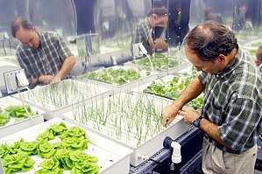

FIGURE 1.2 NASA TESTING HYDROPONICS

**1.4 PROPOSED SYSTEM**

The proposed system aims to develop a system that tends to control the hydroponic mechanism automatically with the help of micro-controller. In this project pH sensoris used to calculate the pH level of the water and DHT 11 sensor to calculate temperature and humidity level inside the greenhouse . Light will be turned on for 16hours in a day.

If pH level is low then base is added into water, if pH level is high acid is added into water. Electrical conductivity should be maintained between 0.8 – 0.12. pH level should be maintained between 5.5 – 6.5.If humidity is more than 60% exhaust fan will be turned on and will be turned off when humidity is less than 60%. If temperature is more than 25 degree Celsius then cooling fan is turned on,if temperature is less than 20 degree Celsius then heater is turned on.

**1.5 SCOPE**

The global hydroponics market is estimated to grow at a CAGR of 6.7% during the 2017-2022 forecast period .The hydroponics market value is anticipated to grow from USDXX millionin 2016 to USD 31436.7 million by 2022. The global hydroponics market is projected to reach USD395.2Million by 2020, growing at a CAGR of 16.8% from 2015 to 2020.Global hydroponics crop value is anticipated to grow from USD18.8billion in 2014 to USD 27.29Billion by 2020 at an estimated CAGR of 6.39% from 2015 to 2020.

**1.6 CHAPTERS OVERVIEW**

The second chapter explains about the block diagram, circuit diagram and working principle of this project, whereas the third chapter gives brief about the hardwares used for the greenhouse environment, there followed by program for the microcontroller is in the fourth chapter. Finally it has information about the output of the project in the chapter 5 and conclusion at chapter 6.

**CHAPTER 2**

**HYDROPONICS**

**INTRODUCTION**

Hydroponics is a subset of [hydroculture](https://en.wikipedia.org/wiki/Hydroponics#Passive_sub-irrigation), which is a method of growing [plants](https://en.wikipedia.org/wiki/Plant) without [soil](https://en.wikipedia.org/wiki/Soil) by using mineral [nutrient](https://en.wikipedia.org/wiki/Nutrient) [solutions](https://en.wikipedia.org/wiki/Solution) in a water solvent.[Terrestrial plants](https://en.wikipedia.org/wiki/Terrestrial_plant) may be grown with only their [roots](https://en.wikipedia.org/wiki/Root) exposed to the mineral solution, or the roots may be supported by an inert medium, such as [perlite](https://en.wikipedia.org/wiki/Perlite)or [gravel](https://en.wikipedia.org/wiki/Gravel).

The nutrients used in hydroponic systems can come from an array of different sources; these can include, but are not limited to, [byproduct](https://en.wikipedia.org/wiki/Byproduct) from fish waste, duck [manure](https://en.wikipedia.org/wiki/Manure), or purchased [chemical fertilizers](https://en.wikipedia.org/wiki/Chemical_fertilizer)

**2.1 HYDROPONICS**

Hydroponics is the practice of growing plants using only water, nutrients, and a growing medium. The word hydroponics comes from the roots “hydro”, meaning water, and “ponos”, meaning labor, this method of gardening does not use soil.​

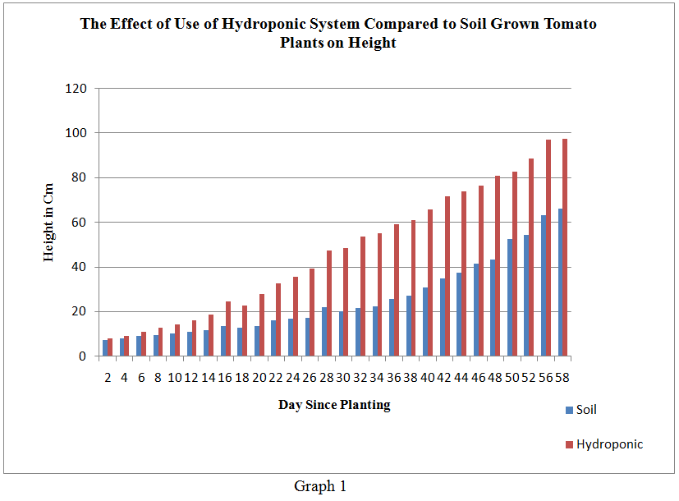The most blatant benefit of hydroponic gardening is the massively increased growth rate of most plants. It's not uncommon for a plant to grow at least 20% faster than soil gardening. On top of that, plants will typically yield at least 25% more than their soil counterparts.This happens because its making it easier for them to get the nutrients they need to grow. When they have to struggle less to find pockets of water or nutrition like they would in soil, they can divert that energy to growth.It's important to keep in mind that these ​benefits apply only ifgarden is maintained carefully. Figure 2.1 shows how tomato grows higher in hydroponics than soil.

FIGURE 2.1 HYDROPONICS VS SOIL-FOR HYBRID TOMATO

**2.2 TYPES OF HYDROPONIC SYSTEMS**

There are six main types of hydroponic systems to choose from:

1. Wick Systems
2. Deep Water Culture (DWC)
3. Nutrient Film Technique (NFT).
4. Ebb and Flow (Flood and Drain)
5. Aeroponics
6. Drip Systems

### 2.3 EBB & FLOW

### Ebb & Flow systems, which are also known by the name Flood and Drain, are a less-commonly seen system. But they're still quite effective and can be the best choice depending on your situation.

An Ebb & Flow system does not expose the roots of your plants to nutrient solution on a constant basis.Instead, it’s grown in a tray filled with a growing medium. The tray is "flooded" with your nutrient solution a few times per day, depending on factors like:

* The size of plants
* The water requirement of plants
* The air temperature
* Where plants are in their growth cycle

Flooding is accomplished by using a reservoir below the tray, a water pump, and a timer to schedule the flooding cycle.

After the tray is flooded, gravity drains the solution back down into the reservoir, where it is being oxygenated by an air pump and air stone. It sits there waiting for the next flood cycle, and the process goes on.

Hydroponic growers choose ebb and flow systems for their flexibility. Most of them will fill the tray with a growing medium of their choice and also add net pots to organize their plants and control the roots a bit more.

**BENEFITS OF EBB & FLOW**

* Efficient use of water and energy
* Highly customizable to your specific needs

**DOWNSIDES OF EBB & FLOW**

* Roots can dry out quickly if environmental conditions are off or the pump or timer fails
* Uses a lot of growing medium

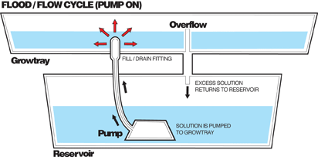

FIGURE 2.2 EBB & FLOW METHOD

# 2.4 HYDROPONIC LETTUCE

Lettuce is the easiest vegetable to grow hydroponically.  Water culture systems, in which plants float directly on top of water while their roots grow down and absorb nutrients, are the most effective and simplistic. A lot of different media options are available to choose from including: Rockwool, coco fiber, vermiculite, pine shavings, river rock, sand, and many more. All of these options have positive and negative aspects, but picking any one of them will allow to grow lettuce without a problem.

Rockwool is the most popular medium choice and is both sterile and porous. If Rockwool is used , be careful to keep it from becoming too saturated. This can lead to root suffocation, stem rot, and root rot.

Grow rock is another popular option that has a neutral pH and holds moisture well. This medium is reusable if cleaned thoroughly, which can be beneficial for growing hydroponically in home, but might be tedious on a larger scale

Before puttinghydroponic system to use, need to use an egg carton or plugs, which are small cells, to create a stable initial environment for plants. Fill plugs with medium of choice and with hydroponic seeds

Carefully, without tugging, take individual seedlings from their cells to the net pots. Align each net pot with the holes that drilled into the floating platform or lid of the container, and

then place them in reservoir. The figure 2.3 shows the difference of the root system of normal soil based and hydroponic based system.

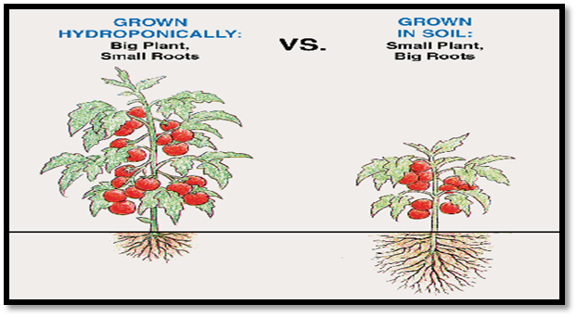

**FIGURE 2.3 HYDROPONICS VS SOIL PLANTS**

A plant’s pH level refers to how acidic or basic it is, and determines whether or not it can properly absorb the nutrients available to it. Frequently test the pH with an inexpensive paper strip test and make sure it’s slightly acidic to almost neutral for the best possible production. Figure 2.4 shows a hydroponically grown lettuce which is fleshier.

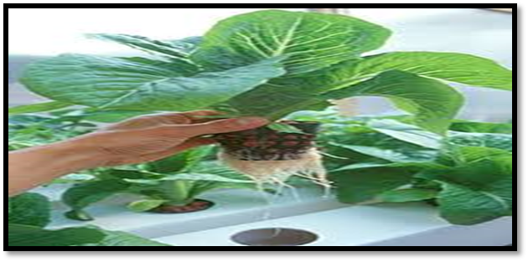

**FIGURE 2.4 HYDROPONIC LETTUCE**

**TABLE 2.1 REQUIREMENTS OF HYDROPONICS LETTUCE**

|  |  |  |
| --- | --- | --- |
| **PLANT** | **PH** | **EC** |
| Lettuce | 5.5-6.5 | 0.8-0.12 |

**CHAPTER - 3**

**BLOCK DIAGRAM AND CIRCUIT DIAGRAM**

**INTRODUCTION**

This chapter elaborates about the block diagram and the circuit diagram of this project. The important buildingblocks of this project are micro-controller(PIC16F887), pH sensor, DHT11 sensor, relays and motors, LCD, power supply and RTC. The circuit diagram gives a detailed idea about how various components are interfaced with the micro-controller.

**3.1 BLOCK DIAGRAM**

The system makes use of a pH sensor that is immersed in the water that we use for hydroponics .The sensor continuously measure the pH value and sends the mandatory information to the microcontroller .the microcontroller in turn processes the input and then controls the 4 motors connected to it. These motors are generally used to control the addition of nutrients and pH controlling elements.

If the pH goes low then acid is added while in the other case when the pH goes high above the preset value then base which is stored in an another vessel is added through the motor. This process controls the pH of the reservoir water, where one motor is connected with fertilizer and the other one is connected with water. The system uses peristaltic pumps to maintain various levels.

Here we are going to calculate the pH level of water using ph sensor and temperature, humidity level in the room using DHT 11 sensor. If pH level is low base is added into water, if PH level is low then base is added into water. pH level should be maintained between 5.5 – 6.5.If humidity level goes above 60% then exhaust fan will be turned on still it normal state(60%),no change will happen if it goes below 60%.If the temperature above 25° Celsius cooling fan will be turned on, if it goes below 20° Celsius then heater will be turned on. The Figure 3.1 shows the Block Diagram of this project.

Relay 1 output is connected to Peristaltic pump 1,Relay 2 output is connected to Peristaltic pump 2 , Relay 3 output is connected to Peristaltic pump 3,Relay 4 output is connected to Circulatory motor ,Relay 5 output is connected to exhaust fan ,Relay 6 output is connected to cooling fan ,Relay 7 output is connected to heater and Relay 8 output is connected to light.

Peristaltic pump 1 inlet tube is given to acid and outlet tube is given to tank.

Peristaltic pump 2 inlet tube is given to base and outlet tube is given to tank.

Peristaltic pump 3 inlet tube is given to fertilizer and outlet tube is given to tank.

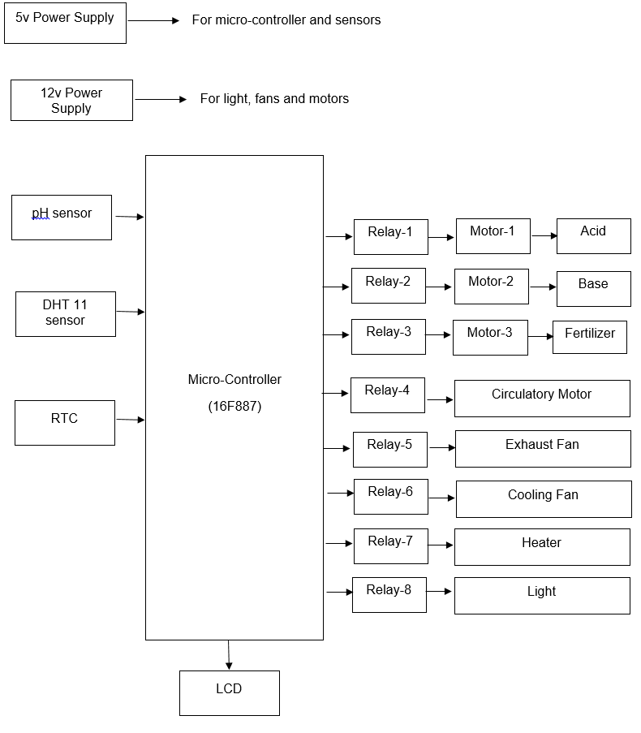

**FIGURE 3.1 BLOCK DIAGRAM**

* **pH SENSOR**

PH Sensor is the measure of acidity or alkalinity of an aqueous solution. If a solution is acidic then it has a pH in the range of 0 to 6.9. If a solution is alkaline then it has a pH in the range of 7.1 to 14. Pure water or deionised water is neutral at pH 7.0.

* **HUMIDITY**

Humidity is the amount of [water vapor](https://en.wikipedia.org/wiki/Water_vapour) present in air. Water vapor, the gaseous state of water, is generally invisible to the human eye. Humidity indicates the likelihood for [precipitation](https://en.wikipedia.org/wiki/Precipitation_(meteorology)), [dew](https://en.wikipedia.org/wiki/Dew), or [fog](https://en.wikipedia.org/wiki/Fog) to be present. When humidity gets too high in greenhouses, plant leaves stand a much better chance of getting wet. Wet foliage, unfortunately, is one of the best ways to ensure a fungal infection or an outbreak of mildew. Fungal diseases such as the Botrytis pathogen or powdery mildew are common greenhouse culprits. When moisture builds up on the roof of the greenhouse and then drips back down, it can splash infected plant leaves and the resulting spray can contaminate nearby plants .Humidity is maintained below 60%.

* **TEMPERATURE**

Temperature is a [physical quantity](https://en.wikipedia.org/wiki/Physical_quantity) expressing [hot and cold](https://en.wikipedia.org/wiki/Heat). It is [measured](https://en.wikipedia.org/wiki/Measurement) with a [thermometer](https://en.wikipedia.org/wiki/Thermometer)[calibrated](https://en.wikipedia.org/wiki/Calibration) in one or more [temperature scales](https://en.wikipedia.org/wiki/Conversion_of_units_of_temperature). The most commonly used scales are the [Celsius scale](https://en.wikipedia.org/wiki/Celsius) (formerly called *centigrade*) (denoted °C), [Fahrenheit scale](https://en.wikipedia.org/wiki/Fahrenheit) (denoted °F), and [Kelvin scale](https://en.wikipedia.org/wiki/Kelvin)(denoted K). Temperature is the primary factor that controls crop timing and plant development. Growing crops at lower temperatures can produce higher-quality plants when light is limited. Crops grown cooler often have more branches and flower buds than crops grown warmer. Temperature is maintained between 20-25 degree Celsius.

* **Light**

Plants have an optimal intensity of light. This is the point at which the process of photosynthesis is maximized and plant growth is greatest. If the level of light is less, growth is reduced. The point where an increase in light intensity will not increase photosynthesis any more is called light saturation. In our project we have used red color light for plants because it is highly effective at regulating growth and development.

**3.2 CIRCIUT DIAGRAM**

This project usesPIC16F887 micro-controller which has 40 pins , 5 ports named A, B, C, D and E. Here 5V and 12V power supply is used which consist of 7805 and 7812 regulator IC . This project has 2 sensors: pH sensor,DHT11 sensor are used. These sensor consist of 3 pins each they are: VSS, GND, output pin . Output pins of pH and DHT11 are connected to pins 2 and 3 respectively .pH sensor is used for sensing the pH level of the water , DHT11 sensor is used for sensing temperature and humidity. It has 9 Relays connected to the 4 Peristaltic pumps, Cooling Fan ,Exhaust Fan , Heater , Light , Circulatory Motor. For displaying the output 16x2 hd 44780 LCD display is used .The Figure 3.2 shows the Circuit Diagram of this project.

This page is for a3 sheet

FIGURE 3.2 CIRCUIT DIAGRAM

**CHAPTER 4**

**HARDWARES USED**

**INTRODUCTION**

The most important components required are Microcontroller(PIC16F887), Relay module, Light, Exhaust fan, Cooling fan, Heater, Peristaltic pump, DHT11 sensor, pH sensor, Power supply and LCD display.

**4.1MICROCONTROLLER – PIC16F887**

The PIC16F887 is one of the latest products from Microchip. It features all the components which modern microcontrollers normally have. For its low price, wide range of application, high quality and easy availability, it is an ideal solution in applications such as: the control of different processes in industry, machine control devices, measurement of different values etc. The Figure 4.1 shows the Pin Diagram of PIC16f887.

PIC16F887 FEATURES

Following table shows the complete features of PIC16F887.

**TABLE 4.2 PIC16F887 FEATURES**

|  |  |
| --- | --- |
| **PIC16F887 Features** | |
| No. of Pins | 40 |
| CPU | 8-Bit PIC |
| Operating Voltage | 2 to 5.5 V |
| Program Memory | 8K |
| Program Memory (Instructions) | 8192 |
| RAM | 368 Bytes |
| EEPROM | 256 Bytes |
| ADC | 10-Bit |
| I/O Ports (5) | A,B,C,D,E |
| I/O Pins | 35 |
| Packages | 40-pin PDIP  44-pin QFN  44-pin TQFP |
| External Oscillator | up to 20 MHz |
| Timer (3) | 16-Bit Timer (1)  8-Bit Timer (2) |
| USART Protocol | 1 |
| I2C Protocol | Yes |
| SPI Protocol | Yes |
| Brown-out Reset | Yes |
| Watchdog Timer | Yes |
| Comparators | 2 |
| Master Synchronous Serial Port (MSSP) module | 1 |
| Capture/Compare/PWM | 16bit/16bit/10bit |
| Power Saving Sleep Mode | Yes |
| Selectable Oscillator Option | Yes |
| Operating Current | 11uA at 32 kHz, 2.0 V  220uA at 4 MHz, 2.0 V |
| Temperature Range | -40 to 125 |
| Oscillator Start-up Timer | Yes |

**PIN DIAGRAM**

The figure 4.1 shows the pin configuration of PIC16F887 microcontroller. This is a 40 pin microcontroller with DIP package. This is also available in 64 pin configuration. This microcontroller has 5 ports. Ports A, B, C, D have 8 pin each. While port E has only 4 pins.

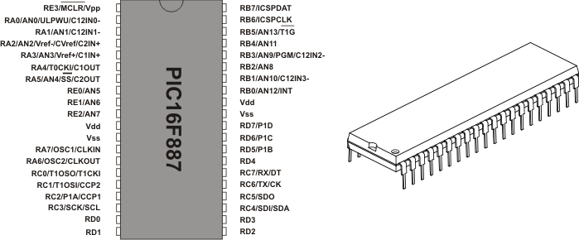

FIGURE 4.1 PIN DIAGRAM

**PORT DESCRIPTIONS**

**PORT A**

PORT A is a 8-bit wide, bidirectional port. The corresponding data direction register is TRISA (Register 3-2). Setting a TRISA bit (= 1) will make the corresponding PORTA pin an input (i.e., disable the output driver). Clearing a TRISA bit (= 0) will make the corresponding PORTA pin an output (i.e., enables output driver and puts the contents of the output latch on the selected pin).

**PORT B**

PORT B is an 8-bit wide, bidirectional port. The corresponding data direction register is TRISB (Register 3-6). Setting a TRISB bit (= 1) will make the corresponding PORTB pin an input (i.e., put the corresponding output driver in a High-Impedance mode). Clearing a TRISB bit (= 0) will make the corresponding PORTB pin an output (i.e., enable the output driver and put the contents of the output latch on the selected pin).

**PORT C**

PORT C is a 8-bit wide, bidirectional port. The corresponding data direction register is TRISC (Register 3-10). Setting a TRISC bit (= 1) will make the corresponding PORTC pin an input (i.e., put the corresponding output driver in a High-Impedance mode). Clearing a TRISC bit (= 0) will make the corresponding PORTC pin an output (i.e., enable the output driver and put the contents of the output latch on the selected pin).

**PORT D**

PORT D is a 8-bit wide, bidirectional port. The corresponding data direction register is TRISD(Register 3-12). Setting a TRISD bit (= 1) will make the corresponding PORTD pin an input (i.e., put the corresponding output driver in a High-Impedance mode).Clearing a TRISD bit (= 0) will make the corresponding PORTD pin an output (i.e., enable the output driver andput the contents of the output latch on the selected pin).

**PORT E**

PORTE is a 4-bit wide, bidirectional port. The corresponding data direction register is TRISE. Setting a TRISE bit (= 1) will make the corresponding PORTE pin an input (i.e., put the

corresponding output driver in a High-Impedance mode). Clearing a TRISE bit (= 0) will make the corresponding PORT E pin an output (i.e., enable the output driver and put the contents of

the output latch on the selected pin). The exception is RE3, which is input only and its TRIS bit will always read as ‘1’.

**ADC PINS DESCRIPTIONS**

PIC16F887 has an inbuilt 10 bit Successive Approximation ADC which is multiplexed among 8 input pins.

The A/D module has high and low-voltage reference input that is software selectable to some combination of VDD, VSS, RA2 or RA3. With 5v as the Vref the resolution of PIC16f887.

The below table shows the ADC input pins multiplexed with other GPIO pins.  
The ADC pin can be enabled by configuring the corresponding ACON1 register.  
When the ADC function is selected for a pin ,then other Digital signals are disconnected from the ADC input pins.

**ADC REGISTERS**

The below table shows the registers associated with ADC.

**TABLE 4.1 ADC REGISTER DESCRIPTION**

|  |  |
| --- | --- |
| ADCON0 | Used to Turn ON the ADC, Select the Sampling Freq and also Start the conversion. |
| ADCON1 | Used to configure the GPIO pins for ADC |
| ADRESH | Holds the higher byte of ADC result |
| ADRESL | Holds the lower byte of ADC result |

**4.2 pH SENSOR**

**pH** is a measure of acidity or alkalinity of a solution, the pH scale ranges from 0 to 14. The pH indicates the concentration of hydrogen [H] + ions present in certain solutions. It can accurately be quantified by a sensor that measures the potential difference between two electrodes: a reference electrode (silver / silver chloride) and a glass electrode that is sensitive to hydrogen ion. This is what form the probe. An electronic circuit is used to condition the signal appropriately and this sensor is used with a micro-controller

pH  probes measure pH by measuring the voltage or potential difference of the solution in which it is dipped. By measuring potential difference, hydrogen ion concentration can be calculated using the Nernst equation which gives the relationship between Hydrogen ion concentration and Voltage or Potential. The Figure 4.2 shows sample pH levels of various liquids.

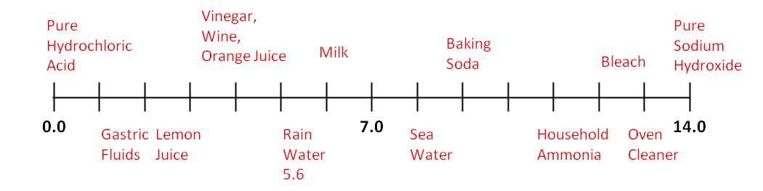

**FIGURE 4.2 pH TABLE**

**4.3 POWER SUPPLY**

A power supply is an electrical device that supplies [electric power](https://en.wikipedia.org/wiki/Electric_power) to an [electrical load](https://en.wikipedia.org/wiki/Electrical_load). The primary function of a power supply is to convert [electric current](https://en.wikipedia.org/wiki/Electric_current) from a source to the correct [voltage](https://en.wikipedia.org/wiki/Voltage), [current](https://en.wikipedia.org/wiki/Electric_current), and [frequency](https://en.wikipedia.org/wiki/Frequency) to power the load. 5v and 12v are used in this project.

**5v POWER SUPPLY**

Input to power supply is 230v AC. A step-down transformer for stepping down the voltage and a bridge rectifier is used. This converts AC to DC. The capacitors are used for filtration. The 7805 regulator IC regulates fixed 5v dc output which is given to microcontroller, motors and sensors. Circuit diagram has been shown in figure 4.3.

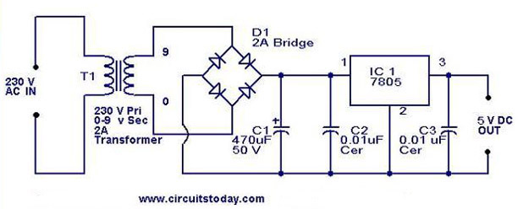

**FIGURE 4.3 5V POWER SUPPLY**

**12v POWER SUPPLY**

Input to power supply is 230v AC. A step-down transformer for stepping down the voltage and a bridge rectifier is used. This converts AC to DC. The capacitors are used for filtration. The 7812 regulator IC regulates fixed 12v dc output which is given to microcontroller, motors and sensors. Circuit diagram has been shown in figure 4.4.

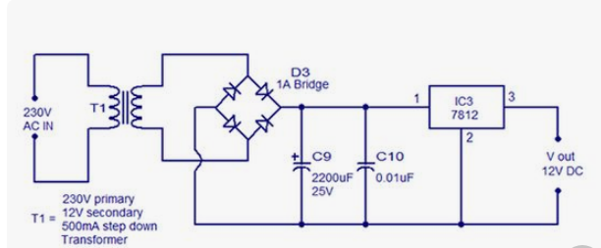

**FIGURE 4.4 12V POWER SUPPLY**

**4.4 LCD DISPLAY**

LCD (Liquid Crystal Display) screen is an electronic display module and find a wide range of applications. A 16x2 LCD display is very basic module and is very commonly used in various devices and circuits. These modules are preferred over [seven segments](http://www.engineersgarage.com/content/seven-segment-display) and other multi segment [LED](http://www.engineersgarage.com/content/led)s. The reasons being: LCDs are economical; easily programmable; have no limitation of displaying special & even [custom characters](http://www.engineersgarage.com/microcontroller/8051projects/create-custom-characters-LCD-AT89C51) (unlike in seven segments), [animations](http://www.engineersgarage.com/microcontroller/8051projects/display-custom-animations-LCD-AT89C51) and so on. A **16x2 LCD** means it can display 16 characters per line and there are 2 such lines. In this LCD each character is displayed in 5x7 pixel matrix. This LCD has two registers, namely, Command and Data.

The command register stores the command instructions given to the LCD. A command is an instruction given to LCD to do a predefined task like initializing it, clearing its screen, setting the cursor position, controlling display etc. The data register stores the data to be displayed on the LCD. The data is the ASCII value of the character to be displayed on the LCD.

**Pin Description**

The most commonly used LCDs found in the market today are 1 Line, 2 Line or 4 Line LCDs which have only 1 controller and support at most of 80 characters, whereas LCDs supporting more than 80 characters make use of 2 HD44780 controllers. The figure 4.5 shows the pin configuration of the LCD display.

Most LCDs with 1 controller has 14 Pins and LCDs with 2 controller has 16 Pins (two pins are extra in both for back-light LED connections). Pin description is shown in the Table 4.2

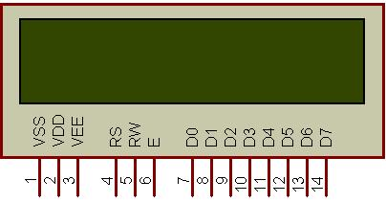

**FIGURE 4.5 LCD DISPLAY**

**TABLE 4.2 PIN DESCRIPTION OF 16X2 CHARACTER LCD**

|  |  |  |
| --- | --- | --- |
| **Pin** | **Name** | **Description** |
| Pin 1 | D7 | Data bus line 7 (MSB) |
| Pin 2 | D6 | Data bus line 6 |
| Pin 3 | D5 | Data bus line 5 |
| Pin 4 | D4 | Data bus line 4 |
| Pin 6 | D2 | Data bus line 2 |
| Pin7 | D1 | Data bus line 1 |
| Pin 8 | D0 | Data bus line 0 (LSB) |
| Pin 9 | EN1 | Enable signal for row 0 and 1 (1stcontroller) |
| Pin 10 | R/W | 0 = Write to LCD module  1 = Read from LCD module |
| Pin 11 | RS | 0 = Instruction input  1 = Data input |
| Pin 12 | VEE | Contrast adjust |
| Pin 13 | VSS | Power supply (GND) |
| Pin 14 | VCC | Power supply (+5V) |
| Pin 15 | EN2 | Enable signal for row 2 and 3 (2ndcontroller) |
| Pin 16 | NC | Not Connected |

**4.5 RELAY MODULE**

Relays are switches that open and close circuits electromechanically or electronically. Relays control one electrical circuit by opening and closing contacts in another circuit. As relay diagrams show, when a relay contact is normally open (NO), there is an open contact when the relay is not energized. When a relay contact is Normally Closed (NC), there is a closed contact when the relay is not energized. In either case, applying electrical current to the contacts will change their state.

Relays are generally used to switch smaller currents in a control circuit and do not usually control power consuming devices except for small motors and Solenoids that draw low amps. Nonetheless, relays can "control" larger voltages and amperes by having an amplifying effect because a small voltage applied to a relays coil can result in a large voltage being switched by the contacts. The Figure 4.6 show a relay module

Protective relays can prevent equipment damage by detecting electrical abnormalities, including overcurrent, undercurrent, overloads and reverse currents. In addition, relays are also widely used to switch starting coils, heating elements, pilot lights and audible alarms. Here 8 relays are used to control the grow light, exhaust fan, cooling fan, heater, circulation pump and peristaltic pumps(acid, base, fertilizer).

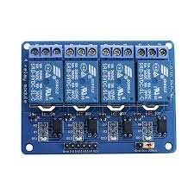

**FIGURE 4.6 RELAY MODULE**

**Pin Diagram and Specification**

A **relay switch**can be divided into two parts: input and output. The input section has a coil which generates magnetic field when a small voltage from an electronic circuit is applied to it. This voltage is called the operating voltage. Commonly used relays are available in different configuration of operating voltages like 6V, 9V, 12V, 24V etc. The output section consists of contactors which connect or disconnect mechanically. In a basic relay there are three contactors: normally open (NO), normally closed (NC) and common (COM). At no input state, the COM is connected to NC. When the operating voltage is applied the relay coil gets energized and the COM changes contact to NO. Different relay configurations are available like SPST, SPDT, [DPDT](http://www.engineersgarage.com/content/dpdt-relay) etc, which have different number of changeover contacts. By using proper combination of contactors, the electrical circuit can be switched on and off. The Figure 4.7 shows the Pin diagram of the Relay.

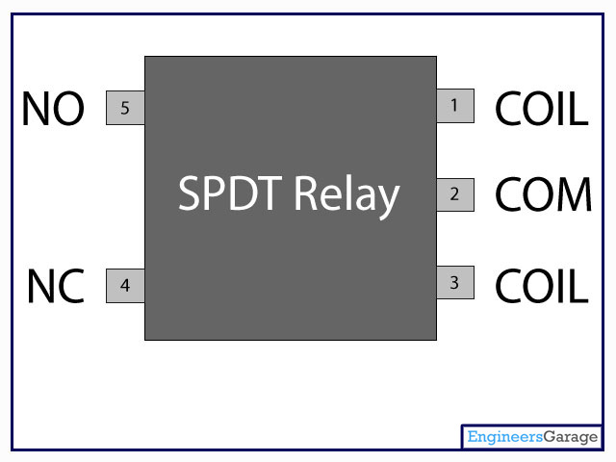

**FIGURE 4.7 PIN DIAGRAM OF RELAY**

**4.6PERISTALTIC PUMP**

A peristaltic pump is a type of positive displacement pump used for pumping a variety of fluids. The fluid is contained within a flexible tube fitted inside a circular pump casing (though linear peristaltic pumps have been made). A [rotor](https://en.wikipedia.org/wiki/Rotor_(turbine)) with a number of "rollers", "shoes", "wipers", or "lobes" attached to the external circumference of the rotor compresses the flexible tube. As the rotor turns, the part of the tube under compression is pinched closed (or "occludes") thus forcing the fluid to be pumped to move through the tube. Additionally, as the tube opens to its natural state after the passing of the cam ("restitution" or "resilience") fluid flow is induced to the pump. This process is called [peristalsis](https://en.wikipedia.org/wiki/Peristalsis) and is used in many biological systems such as the [gastrointestinal tract](https://en.wikipedia.org/wiki/Gastrointestinal_tract).

Typically, there will be two or more rollers, or wipers, occluding the tube, trapping between them a body of fluid. The body of fluid is then transported, at ambient pressure, toward the pump outlet. Peristaltic pumps may run continuously, or they may be indexed through partial revolutions to deliver smaller amounts of fluid.

The fluid is contained within a flexible hose or tube fitted inside the pump casing. The actual pumping principle, called peristalsis, is based on alternating compression and relaxation of the hose or tube, drawing content in and propelling product away from the pump.

A rotating shoe or roller passes along the length of the hose or tube creating a temporary seal between the suction and discharge sides of the pump. As the pump’s rotor turns this sealing pressure moves along the tube or hose forcing product to move away from the pump and into the discharge line. Figure 4.8 shows the peristaltic pump.

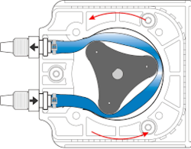

**FIGURE 4.8 PERISTALTIC PUMP**

Where the pressure has been released the hose or tube recovers creating a vacuum, which draws the product into the suction side of the pump, the priming mechanism.

**4.7DHT11 SENSOR**

The DHT11 is a basic, ultra low-cost digital temperature and humidity sensor. It uses a capacitive humidity sensor and a thermistor to measure the surrounding air, and spits out a digital signal on the data pin (no analog input pins needed). It’s fairly simple to use, but requires careful timing to grab data.

This DHT11 Temperature and Humidity Sensor features a calibrated digital signal output with the temperature and humidity sensor capability. It is integrated  with a high-performance 8-bit microcontroller. Its technology ensures the high reliability and excellent long-term stability.  This sensor includes a resistive element and a sensor for wet NTC temperature measuring devices. It has excellent quality, fast response, anti-interference ability and high performance.

Each DHT11 sensors features extremely accurate calibration of humidity calibration chamber. The calibration coefficients stored in the OTP program memory, internal sensors detect signals in the process, this is known as calibration coefficients. The single-wire serial interface system is integrated to become quick and easy. Small size, low power, signal transmission distance up to 20 meters, enabling a variety of applications and even the most demanding ones The Figure 4.9 shows DHT11 sensor.

**Specification**

* Supply Voltage: +5 V
* Temperature range :0-50 °C error of ± 2 °C
* Humidity :20-90% RH ± 5% RH error
* Interface: Digital

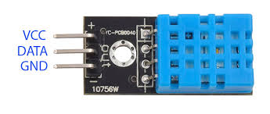

**FIGURE 4.9 DHT 11 SENSOR**

**4.8EXHAUST FAN**

Exhaust fan work by sucking hot or humid air out of a small, localized area, allowing fresh air to enter from elsewhere (perhaps a doorway or vent) in order to replace it. The warm air that's drawn out using an exhaust fan is then pulled through a ducting system and expelled outside. The figure 4.7 shows the exhaust fan.

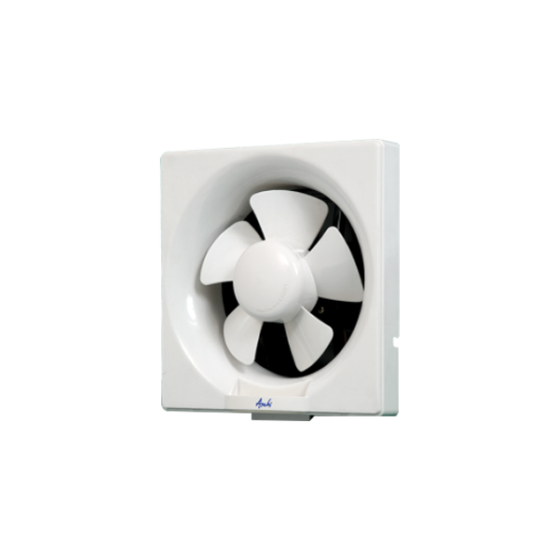

**FIGURE 4.10 EXHAUST FAN**

Move and refresh the stagnant air in greenhouse or building to create a healthier and more productive growing environment. These greenhouse exhaust fans are great for reducing plant and worker heat stress. Exhaust fans provide excellent ventilation for high tunnels and cold frames. Create a cooler more comfortable growing environment, which can directly contribute to productivity, quality and profitability for our greenhouse project. Exhaust fans also works great in workshops and building.

**4.9 COOLING FAN**

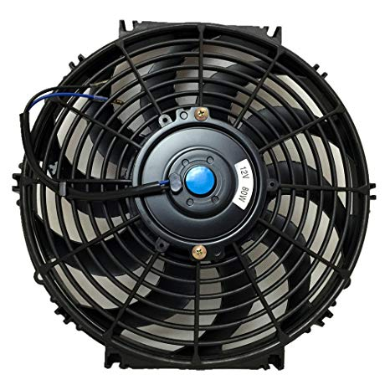 A Cooling fan is any fan inside, or attached to, a computer case used for activecooling, and may refer to fans that draw cooler air into the case from the outside, expel warm air from inside, or move air across a heat sink to cool a particular component. Figure 4.8 shows a Cooling fan.

**FIGURE 4.11 COOLING FAN**

During periods of extreme heat the temperature inside the greenhouse could exceed that outside by 10-20°F even with a well-designed fan ventilation system. This puts a stress on plants, reducing the quality and growth. Evaporative cooling which uses the heat in the air to evaporate the water from the leaf and other wetted surfaces can be used to cool the greenhouse as much as 10-20°F below outside temperature. Evaporative cooling works best when the humidity in the outside air is low.

**4.10 HEATER**

Electric heatingis a process in which [electrical energy](https://en.wikipedia.org/wiki/Electrical_energy) is converted to [heat energy](https://en.wikipedia.org/wiki/Heat_energy). Common applications include [space heating](https://en.wikipedia.org/wiki/Space_heating), [cooking](https://en.wikipedia.org/wiki/Cooking), [water heating](https://en.wikipedia.org/wiki/Water_heating) and industrial processes. An electricheater is an [electrical](https://en.wikipedia.org/wiki/Electricity) device that converts an electric current into heat. The [heating element](https://en.wikipedia.org/wiki/Heating_element) inside every electric heater is an electrical [resistor](https://en.wikipedia.org/wiki/Resistor), and works on the principle of [Joule heating](https://en.wikipedia.org/wiki/Joule_heating): an [electric current](https://en.wikipedia.org/wiki/Electric_current) passing through a resistor will convert that electrical energy into heat energy. The figure 4.9 shows the heater.

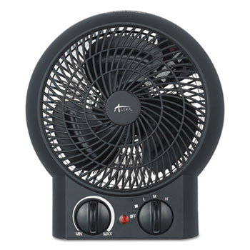

**FIGURE 4.12 HEATER**

Heating a greenhouse is essential for securing the survival of your plants when the temperature drops outside, these electric fan heaters are the perfect solution. The internal fans on the heaters provide good air movement that spreads the heat around the whole greenhouse, making sure the entire greenhouse is heated to an appropriate temperature. On all of our greenhouse heaters you can regulate the temperature using an in-built thermostat, allowing to control the temperature as closely as possible. This good circulation of heat is vital for staving off the damp and disease that can often be found in greenhouses in winter, protecting your plants from the elements as much as possible.

**4.11 GROW LIGHT**

LED grow lights are composed of [light-emitting diodes](https://en.wikipedia.org/wiki/Light-emitting_diode), usually in a casing with a [heat sink](https://en.wikipedia.org/wiki/Heat_sink) and built-in fans. LED grow lights do not usually require a separate ballast and can be plugged directly into a standard electrical socket.

LED grow lights vary in color depending on the intended use. It is known from the study of [photomorphogenes is](https://en.wikipedia.org/wiki/Photomorphogenesis) that green, red, far-red and blue light spectra have an effect on root formation, plant growth, and flowering, but there are not enough scientific studies or field-tested trials using LED grow lights to recommended specific color ratios for optimal plant growth under LED grow lights. It has been shown that many plants will grow normally if given both red and blue light. However, many studies indicate that red and blue light only provides the most cost efficient method of growth, plant growth is still better under light supplemented with green.

Red and blue LED grow lights provide a full spectrum of light designed to mimic natural light, providing plants a balanced spectrum of red, blue and green. The spectrum used varies, however, white LED grow lights are designed to emit similar amounts of red and blue light with the added green light to appear white. White LED grow lights are often used for supplemental lighting in home and office spaces.

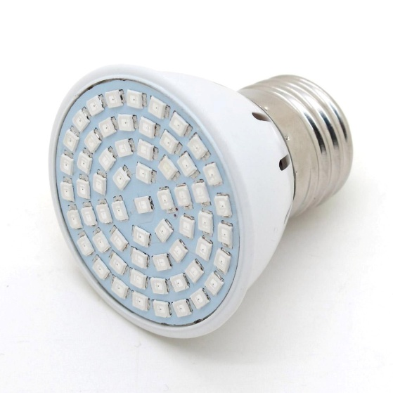

**FIGURE 4.13 GROW LIGHT**

A large number of plant species have been assessed in greenhouse trials to make sure plants have higher quality in biomass and biochemical ingredients even higher or comparable with field conditions. Plant performance of mint, basil, lentil, lettuce, cabbage, parsley, carrot were measured by assessing health and vigor of plants and success in promoting growth.

Generally, LED grow lights come in 2- to 5-watt varieties, meaning they output about 120 to 300 lumens. This grow LED works in 230v 17 watts of electricity, giving them the ability to output roughly 1,020 lumens. The LED manufacturers at Illumitex note that LED lights give off less heat than other grow lights, averaging an output of about 3.4 British thermal units per hour, compared to the 85-BTU-per-hour rate of incandescent bulbs.

**CHAPTER 5**

**SOFTWARE USED**

**INTRODUCTION**

MPLAB is a proprietary freeware [integrated development environment](https://en.wikipedia.org/wiki/Integrated_development_environment) for the development of [embedded applications](https://en.wikipedia.org/wiki/Embedded_system) on [PIC](https://en.wikipedia.org/wiki/PIC_Microcontroller) and [dsPIC](https://en.wikipedia.org/wiki/PIC_microcontroller#PIC24_and_dsPIC_16-bit_microcontrollers) [microcontrollers](https://en.wikipedia.org/wiki/Microcontroller), and is developed by [Microchip Technology](https://en.wikipedia.org/wiki/Microchip_Technology). MPLAB V8.66 is an edition of MPLAB, and is developed on the [NetBeans](https://en.wikipedia.org/wiki/NetBeans) platform. It support project management, code editing, debugging and programming of Microchip 8-bit PIC and AVR (including ATMEGA) microcontrollers, 16-bit PIC24 and dsPIC microcontrollers, as well as 32-bit SAM (ARM) and PIC32 (MIPS) microcontrollers. MPLAB is designed to work with MPLAB-certified devices such as the [MPLAB ICD 3](https://en.wikipedia.org/wiki/MPLAB_devices#MPLAB_ICD_3) and [MPLAB REAL ICE](https://en.wikipedia.org/wiki/MPLAB_devices#MPLAB_REAL_ICE), for programming and debugging PIC microcontrollers using a [personal computer](https://en.wikipedia.org/wiki/Personal_computer). [PICKit](https://en.wikipedia.org/wiki/PICKit) programmers are also supported by MPLAB. It supports automatic code generation with the MPLAB Code Configurator and the MPLAB Harmony Configurator plugins.

**5.1 PROCEDURE FOR EDITING AND COMPILING**

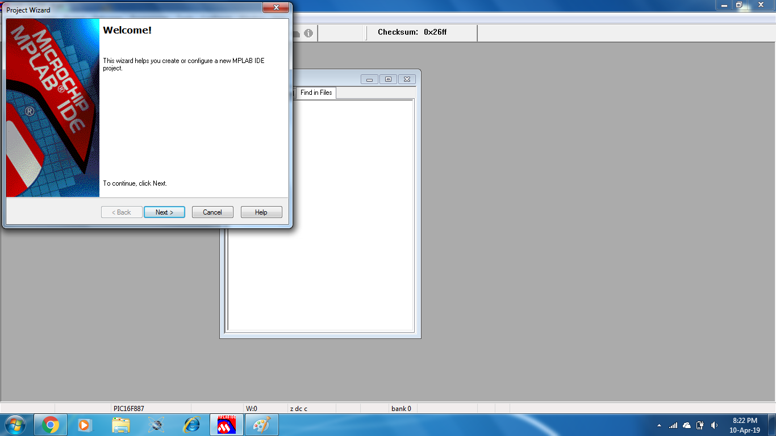**Step 1 :** MPLAB IDE v8.66 is opened. The welcome window appears and then click next.

**FIGURE 5.1 INITIALIZATION WINDOW**

**Step 2 :** Project tab is clicked. A drop down list appears from which the project wizard window is selected.

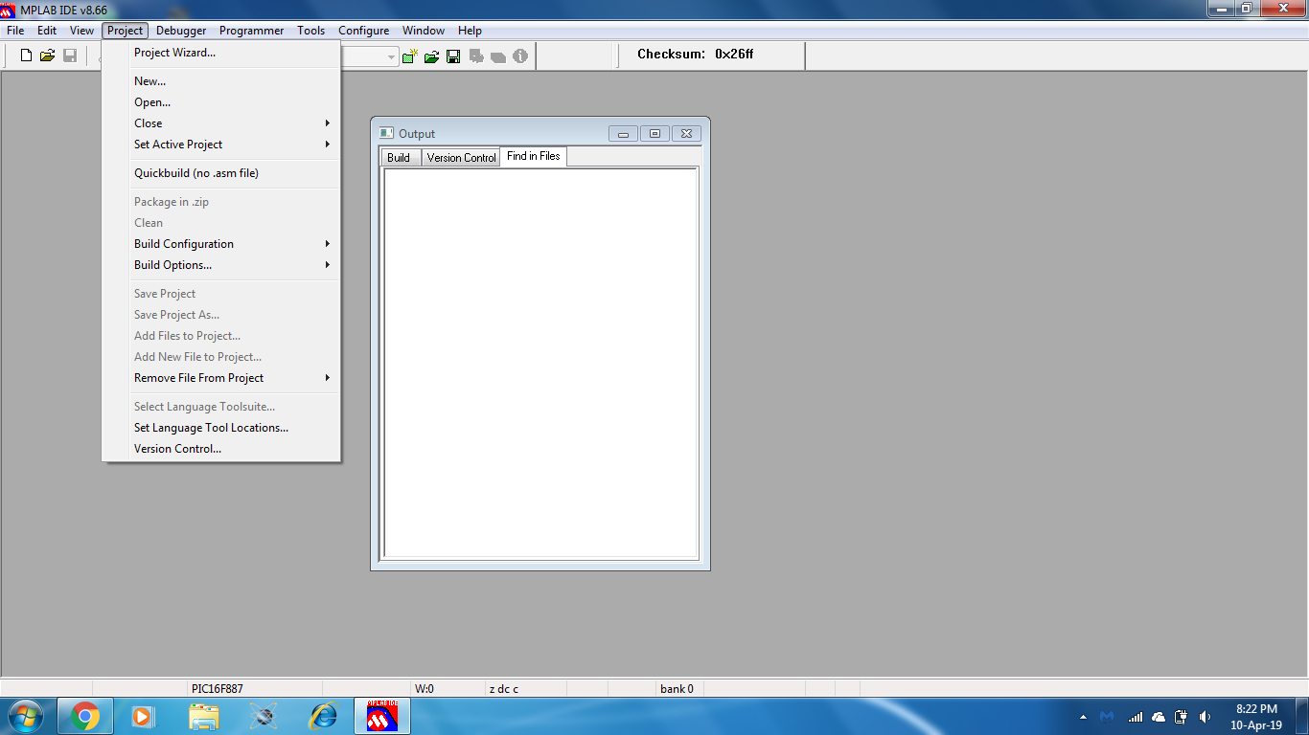

**FIGURE 5.2 OPEN PROJECT WIZARD WINDOW**

**Step 3 :**Microcontroller is selected from the list of options. This project makes use of PIC16F887

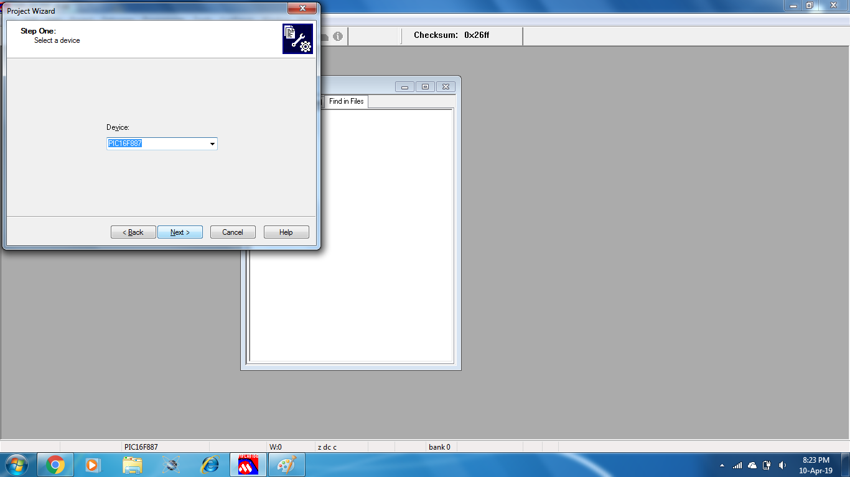

**FIGURE 5.3 PROJECT WIZARD WINDOW : SELECT DEVICE**

**Step 4 :**A location is selected to store the program.

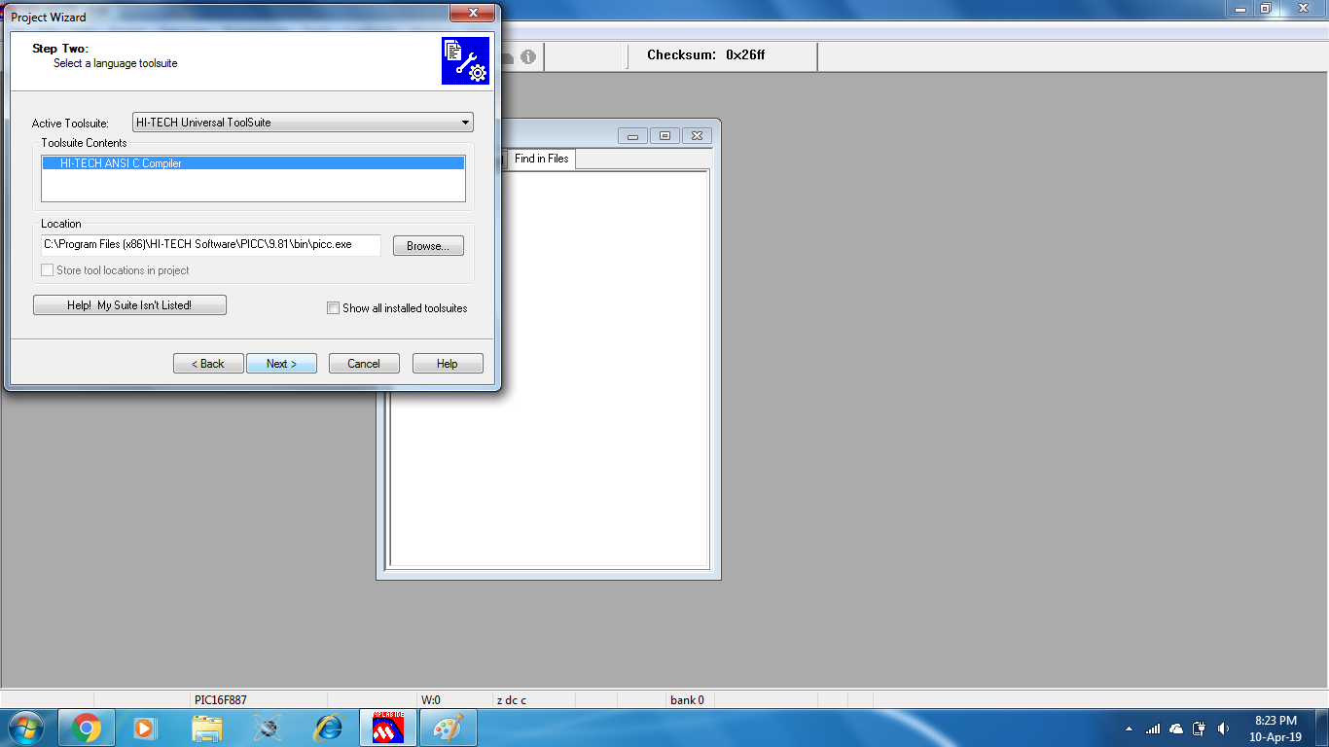

**FIGURE 5.4 PROJECT WIZARD WINDOW : SELECT LOCATION**

**Step 5:**An appropriate name is given for the project.

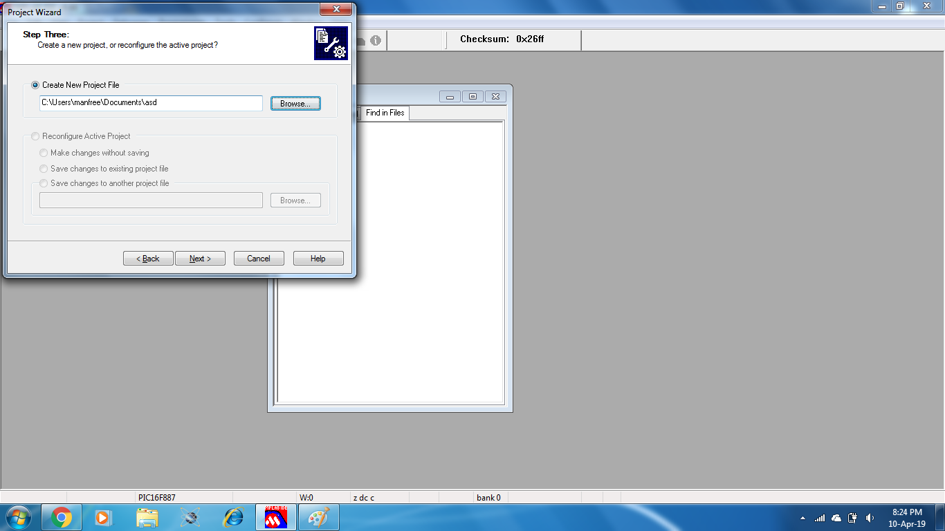

**FIGURE 5.5 PROJECT WIZARD WINDOW : CREATE A NEW PROJECT**

**Step 6:**The existing files are added to the project.

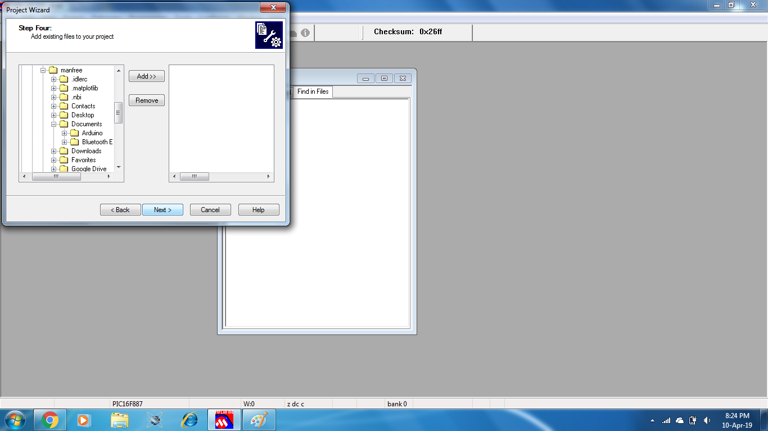

**FIGURE 5.6 PROJECT WIZARD WINDOW : ADD THE EXISTING FILE**

**Step 7:**A project summary report appears and then click finish.

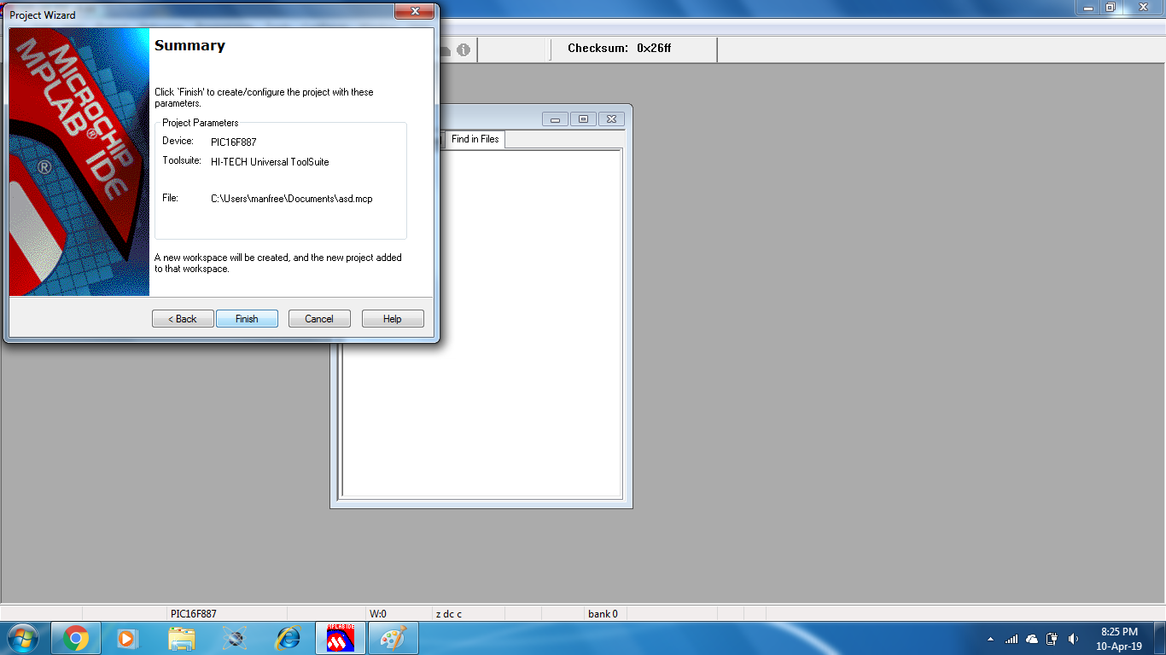

**FIGURE 5.7 PROJECT WIZARD WINDOW : PROJECT SUMMARY**

**5.2 PROCEDURE FOR DOWNLOADING THE CODE**

**Step 1 :**Programmer option is selected. A drop down list appears which has a list of the options to chose from.

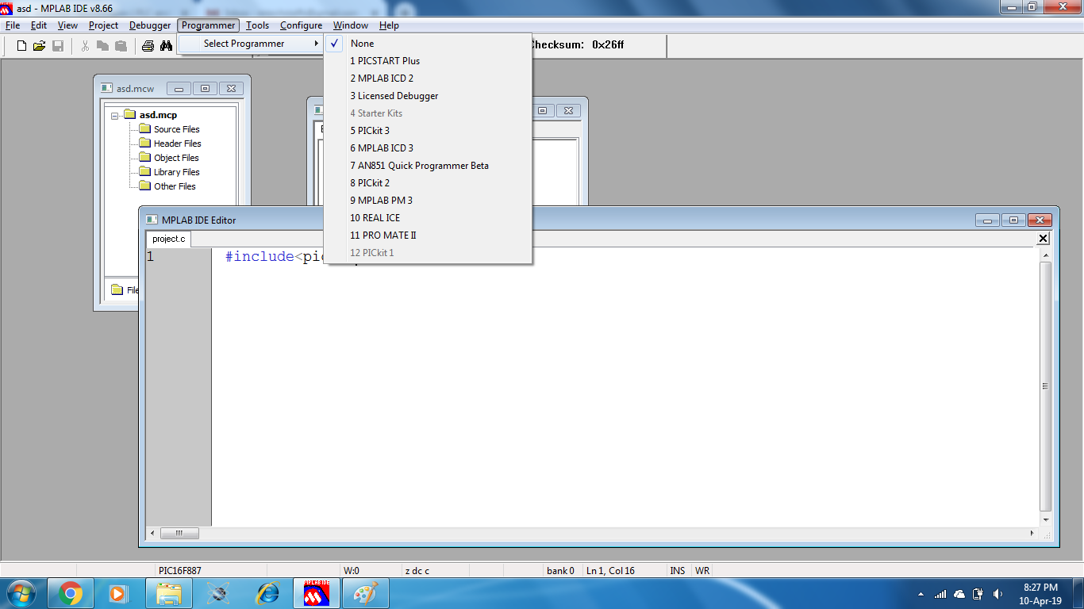

**FIGURE 5.8 PROGRAMMER OPTION**

**Step 2:**PICkit 2 is selected from the options.

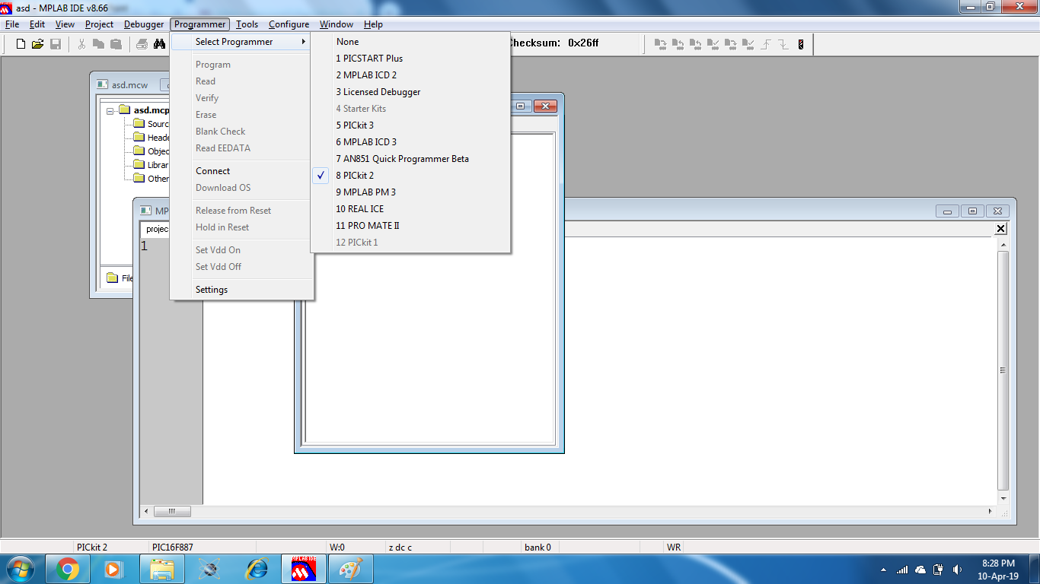

**FIGURE 5.9 PROGRAMMER OPTION : SELECT PROGRAMMER : PICKIT 2**

**Step 3:**Connect option is selected from the programmer tab. The downlading starts.

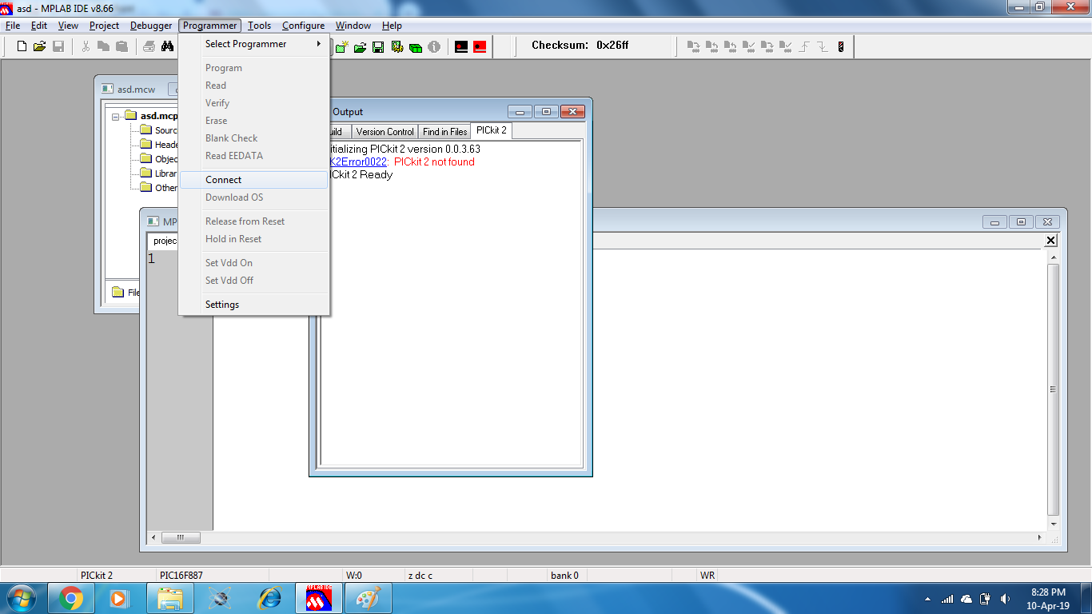

**FIGURE 5.10 PROGRAMMER OPTION : CONNECT**

**CHAPTER 6**

**PROGRAM**

#include<pic.h>

__CONFIG(0x2CE2);

#define _XTAL_FREQ 10000000

#define I2C_FREQ 1000000

#define RS RE2

#define RW RE1

#define EN RE0

#define LCD PORTD

//PLANT RELATED

#define Acid RB5

#define Base RC0

#define Fertilizer RB6

#define Recircle RB7

//use 12 v relay

#define light RB0

#define cooler RB1

#define heater RB2

#define ex RB3

unsigned char Check, T_byte1, T_byte2,

RH_byte1, RH_byte2, Ch ;

unsigned Temp, RH, Sum ;

float ph_val7,ph_val_f;

unsigned char s[20];

unsigned int ph_value,ph_val,f,c,count,motor,var3,var4,var5,var6,var6_w,var7,var8,var_w,var_f,var2,var9,flag2,flag3,flag4,flag5,flag6,flag7,flag8,flag9;

unsignedintrec,five_min;

const char *day[8]={"Em","SUN","MON","TUE","WED","THU","FRI","SAT"};

unsigned char sec,min,hur;

unsigned char date,month,year,days,pre_date=0;

void pulse()

{

EN=1;

__delay_ms(10);

EN=0;

__delay_ms(10);

}

voidlcd_cmd(char a)

{

RS=0;

RW=0;

LCD=((a)&0xF0);

pulse();

RS=0;

RW=0;

LCD=((a&0x0f)<<4);

pulse();

}

voidlcd_digit(char x)

{

RS=1;

RW=0;

LCD=(x&0xF0);

pulse();

RS=1;

RW=0;

LCD=((x&0x0f)<<4);

pulse();

}

void string(const char *p)

{

while(*p)

{

lcd_digit(*p);

p++;

}

}

//PH

voidadc()

{

ADCON0=0x83;

ADCON1=0x80;

GO=1;

while(GO);

ph_value=((ADRESH<<8)|ADRESL);

if((0<ph_value)&&(ph_value<20))

ph_val=8;

if((20<=ph_value)&&(ph_value<=60))

ph_val=7;

if((80<ph_value)&&(ph_value<=130))

ph_val=6;

if((150<ph_value)&&(ph_value<=250))

ph_val=5;

if((300<ph_value)&&(ph_value<=400))

ph_val=4;

if((400<ph_value)&&(ph_value<=550))

ph_val=3;

if((550<ph_value))//&&(ph_value<=550))

ph_val=2;

lcd_cmd(0x8A);

string("PH:");

lcd_digit(ph_val+0x30);

switch(ph_val)

{

case 2:RB5=0;Fertilizer=0;

flag3=flag4=flag5=flag6=flag7=flag8=flag9=0;

if(flag2==0)

{

var2=sec;

flag2=1;

}

if(((var2>=sec)&&(sec<=var2+4))&&(flag2==1))

{

Base=1;

}

else

{

Base=0;

flag2=2;

}

if(flag2==2)

if(sec==(var2+10))

{

flag2=0;

}

break;

case 3: RB5=0;Fertilizer=0;

flag2=flag4=flag5=flag6=flag7=flag8=flag9=0;

if(flag3==0)

{

var3=sec;

flag3=1;

}

if(((var3>=sec)&&(sec<=var3+4))&&(flag3==1))

{

Base=1;

}

else

{

Base=0;

flag3=2;

}

if(flag3==2)

if(sec==(var3+10))

{

flag3=0;

}

break;

case 4: flag2=flag3=flag5=flag6=flag7=flag8=flag9=0;RB5=0;Fertilizer=0;

if(flag4==0)

{

var4=sec;

flag4=1;

}

if(((var4>=sec)&&(sec<=var4+4))&&(flag4==1))

{

Base=1;

}

else

{

Base=0;

flag4=2;

}

if(flag4==2)

if(sec==(var4+10))

{

flag4=0;

}

break;

case 5: flag2=flag4=flag3=flag6=flag7=flag8=flag9=0;RB5=0;Fertilizer=0;

if(flag5==0)

{

var5=sec;

flag5=1;

}

if(((var5>=sec)&&(sec<=var5))&&(flag5==1))

{

Base=1;

}

else

{

Base=0;

flag5=2;

}

if(flag5==2)

if(sec==(var5+10))

{

flag5=0;

}

break;

case 6:flag2=flag4=flag5=flag3=flag7=flag8=flag9=0;

Base=0;RB5=0;

if(flag6==0)

{

var6=sec;

flag6=1;

}

if(((var6>=sec)&&(sec<=var6+2))&&(flag6==1))

{

Fertilizer=1;

}

else

{

Fertilizer=0;

flag6=2;

}

break;

case 7: flag2=flag4=flag5=flag6=flag3=flag8=flag9=0;

Base=0;

if(flag7==0)

{

var7=sec;

flag7=1;

}

if((var7==sec)&&(flag7==1))

{

RB5=1;

}

else

{

RB5=0;

flag7=2;

}

if(flag7==2)

if(sec==(var7+10))

{

flag7=0;

}

break;

case 8:flag2=flag4=flag5=flag6=flag7=flag3=flag9=0;Base=0;Fertilizer=0;

if(flag8==0)

{

var8=sec;

flag8=1;

}

if(((var8>=sec)&&(sec<=var8+4))&&(flag8==1))

{

RB5=1;

}

else

{

RB5=0;

flag8=2;

}

if(flag8==2)

if((sec>=(var8+10))&&(sec<=(var8+14)))

{

flag8=0;

}

break;

case 9:flag2=flag4=flag5=flag6=flag7=flag8=flag3=0;Base=0;Fertilizer=0;

if(flag9==0)

{

var9=sec;

flag9=1;

}

if(((var9>=sec)&&(sec<=var9+4))&&(flag9==1))

{

RB5=1;

}

else

{

RB5=0;

flag9=2;

}

if(flag9==2)

if((sec>=var9+10)||(sec<=var9+14))

{

flag9=0;

}

break;

}

}

//i2c

void i2c_intialization(void)

{

TRISC3=1;

TRISC4=1;

SSPSTAT=0X80;

SSPCON=0X28;

SSPCON2=0X00;

SSPADD=(_XTAL_FREQ/I2C_FREQ);

ACKEN=1;

}

void i2c_start()

{

SEN=1;

while(SEN);

}

void i2c_stop()

{

PEN=1;

while(PEN);

}

void i2c_restart()

{

RSEN=1;

while(SSPIF==0);

SSPIF=0;

}

void i2c_wait()

{

while((SSPCON2&0X1F)||(SSPSTAT&0X04));

}

void i2c_send(unsigned char dat)

{

SSPBUF=dat;

while(BF==0);

i2c_wait();

}

unsigned char i2c_read(void)

{

unsigned char temp;

RCEN=1;

while(SSPIF==0);

SSPIF=0;

while(!BF);

temp=SSPBUF;

(ACKSTAT==1);

ACKSTAT=1;

i2c_wait();

return temp;

}

voidlcd_time(unsigned char dis_addrs)

{

sec=read_rtc(0x00);

min=read_rtc(0x01);

hur=read_rtc(0x02);

lcd_cmd(dis_addrs);

lcd_digit(((hur&0b00110000)>>4)+0X30); //Seperate 10 Hours

lcd_digit((hur&0X0F)+0X30); //Seperate Hours

lcd_digit(':');

lcd_cmd(dis_addrs+3);

lcd_digit(((min&0X70)>>4)+0X30); //seperate 10 Minutes

lcd_digit((min&0X0F)+0X30); //seperate Minutes

lcd_digit(':');

lcd_cmd(dis_addrs+6);

lcd_digit(((sec&0X70)>>4)+0x30); //seperate 10 Seconds

lcd_digit((sec&0X0F)+0X30);

}

voidlcd_date()

{

days=read_rtc(0x03);

date=read_rtc(0x04);

month=read_rtc(0x05);

year=read_rtc(0x06);

}

voidStartSignal(){

TRISA1 = 0; //Configure RD0 as output

RA1 = 0; //RD0 sends 0 to the sensor

__delay_ms(18);

RA1 = 1; //RD0 sends 1 to the sensor

__delay_us(30);

TRISA1 = 1; //Configure RD0 as input

}

//////////////////////////////

charReadData(){

chari, j;

for(j = 0; j < 8; j++){

while(!RA1); //Wait until PORTD.F0 goes HIGH

__delay_us(30);

if(RA1 == 0)

i&= ~(1<<(7 - j)); //Clear bit (7-b)

else {i|= (1 << (7 - j)); //Set bit (7-b)

while(RA1);} //Wait until PORTD.F0 goes LOW

}

returni;

}

//////////////////////////////

void main() {

TRISC0=0;

RC0=0;

TRISD=0X00;

TRISE=0X00;

TRISB=0X10;

TRISA=0x03;

PORTA=0x00;

PORTD=0X0F;

PORTE=0X00;

PORTB=0X0F;

ANSEL=0X00;

ANSELH=0X00;

OPTION_REG=0x80;

i2c_intialization();

lcd_cmd(0x02);

lcd_cmd(0x28);

lcd_cmd(0x0E);

lcd_cmd(0x80);

lcd_cmd(0x01);

while(1){

pre_date=eeprom_read(0);

adc();

CheckResponse();

if(Check == 1){

RH_byte1 = ReadData();

RH_byte2 = ReadData();

T_byte1 = ReadData();

T_byte2 = ReadData();

Sum = ReadData();

if(Sum == ((RH_byte1+RH_byte2+T_byte1+T_byte2) & 0XFF)){

Temp = T_byte1;

RH = RH_byte1;

lcd_cmd(0xC0);

string("Tem:");

lcd_digit(48 + ((Temp / 10) % 10));

lcd_digit(48 + (Temp % 10));

lcd_digit('C');

lcd_cmd(0xC9);

string("Hum:");

lcd_digit(48 + ((RH / 10) % 10));

lcd_digit (48 + (RH % 10));

lcd_digit ('%');

}

}

lcd_time(0X80);

lcd_date();

//light on 16 hur and off 8 hur

if(hur==0x8)

{

light=0;

}

if(hur==0x00 )

light=1;

//fertilizer one day 1 sec ON

if(date>pre_date)

{

if(hur==0x08&&min==0x00&&(sec>=0x00&&sec<=0x03))

{

Fertilizer=1;

}

else if(hur==0x08&&min==0x00&&(sec>0x03&&sec<=0x06))

{

Fertilizer=0;

eeprom_write(0,date);

}

else{Fertilizer=0;}

}

//recircule for 5 min

if(rec<hur)

{

five_min=1;

}

if(five_min==1)

{

if(min<0x05)

{

Recircle=1;

}

else

{

Recircle=0;

five_min=0;

}

}

rec=hur;

if(Temp<20)

{

heater=0;

}

else

{

heater=1;

}

if(Temp>25)

{

cooler=0;

}

else

{

cooler=1;

}

if(RH>65)

{

ex=0;

}

else

{

ex=1;

}

}

**CHAPTER 7**

**OUTPUT**

**INTRODUCTION**

This chapter deals with the output obtained from greenhouse environmental project. The hardware module before and after turning the module has been shown.

**6.1 HARDWARE MODULE**

The figure 6.1 consists of the hardware module consisting of controlling circuits, main reservoir, plant growing module, circulation module, acid/base/fertilizer/water storages.

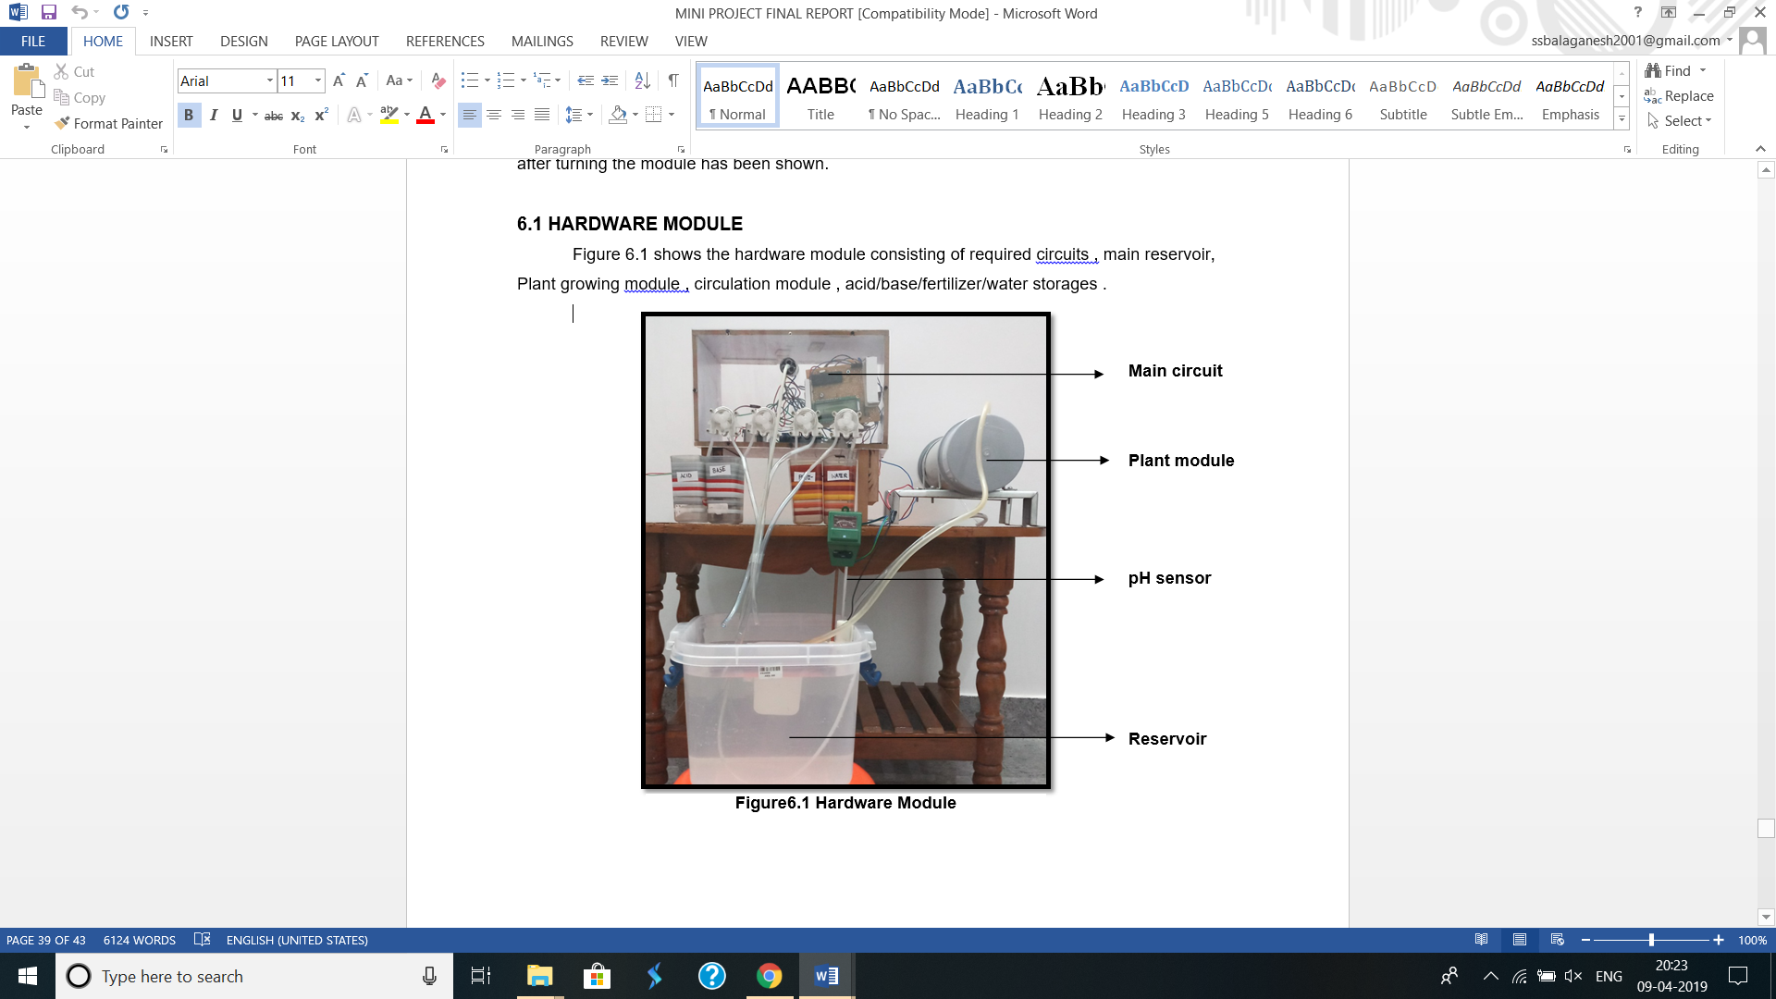

**FIGURE 6.1 HARDWARE MODULE**

The green house is the controlled environment within which the plant is being grown. It consists of a growlight for illumination. A cooling fan and a heater are used for temperature control. The figure 6.2 shows the green house setup.

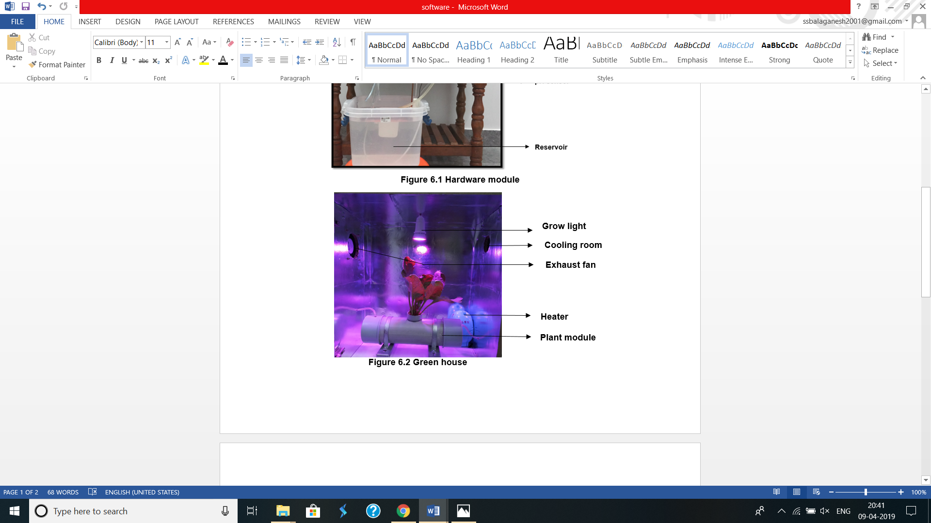

FIGURE 6.2 GREEN HOUSE

**6.2 HARDWARE MODULE BEFORE TURNING ON**

The figure 6.3 shows LCD display just after turning on.

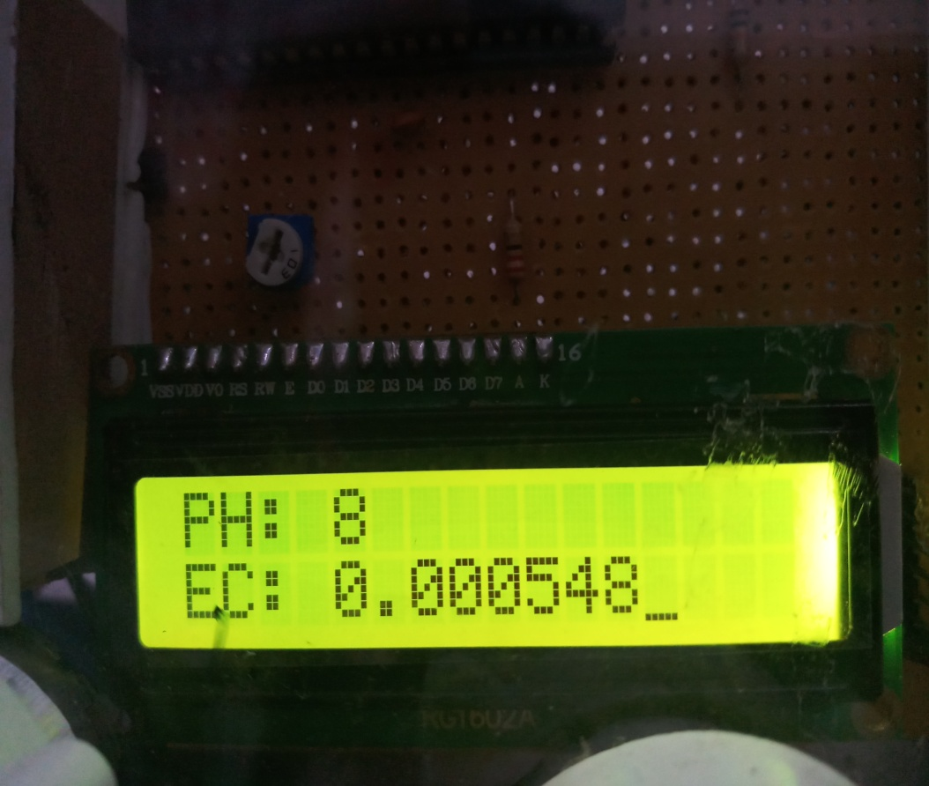

FIGURE 6.3 LCD BEFORE PROCESS

The figure 6.4 showing the pH sensors output before adding the required constituents into the reservoir. Its pH value is around 8.the reservoir consists of hard water from tap.

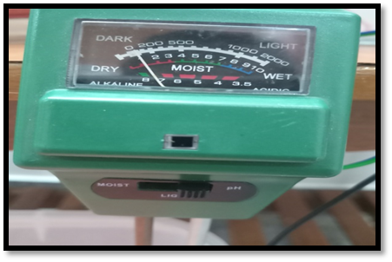

FIGURE 6.4 pH SENSORS VALUE INITIALLY

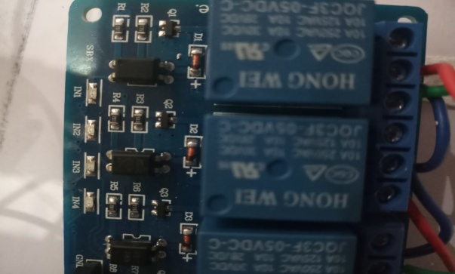The figure 6.5 shows the relay module which is off, which means that no motor is turned ON

FIGURE 6.5 RELAYS TURNED OFF

The figure 6.6 shows Grow Light is OFF

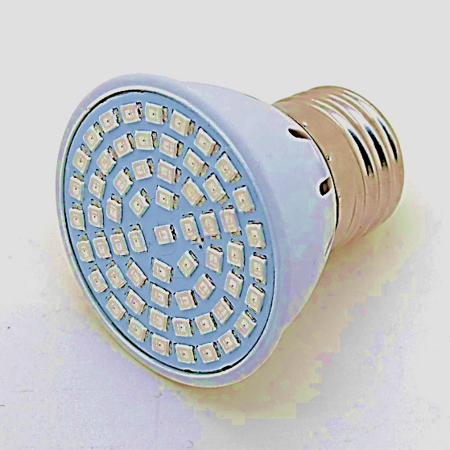

FIGURE 6.6 GROW LIGHT IS OFF

The figure 6.7 Cooling Fan is OFF

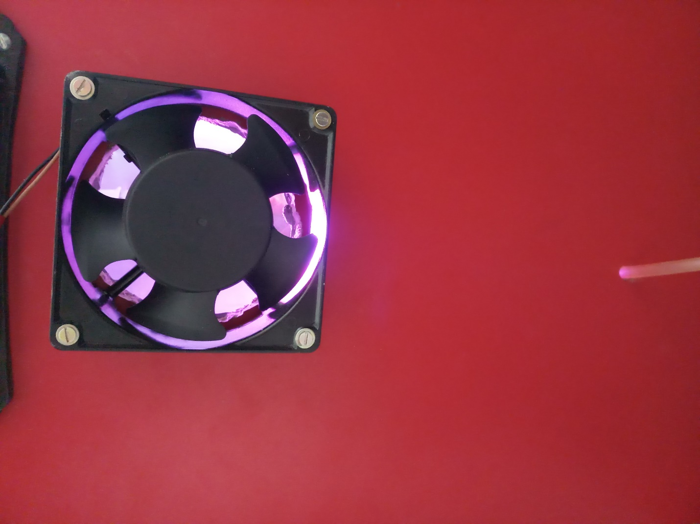

FIGURE 6.7 COOLING FAN IS OFF

**6.3 HARWARE MODULE AFTER TURNING ON**

The figure 6.8 shows the LCD display after addition of acid and fertilizer into the reservoir.

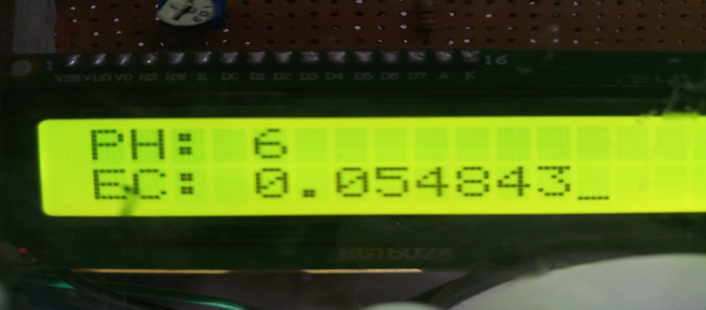

FIGURE 6.8 LCD DISPLAY AFTER PROCESS

The figure 6.9 shows the corrected pH value.

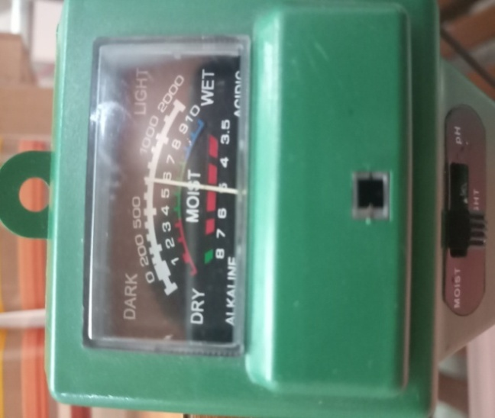

FIGURE 6.9 PH SENSORS OUTPUT

The figure 6.10 shows the output of the relays.

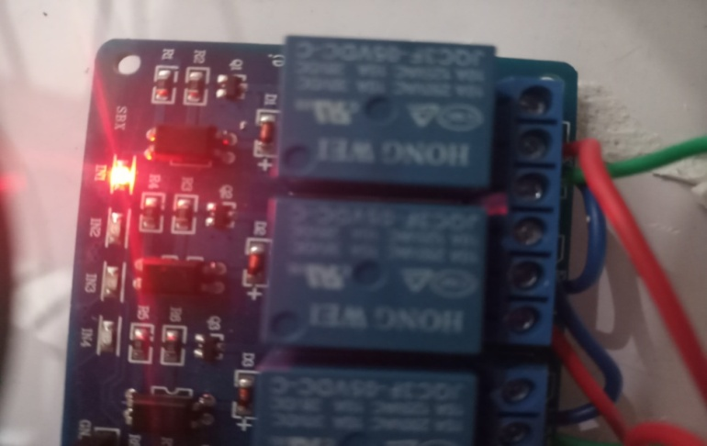

FIGURE 6.10 RELAY MODULE AFTER TURNING ON

It has been programmed to turn on the light 16hours and turn it off for 8 hours. The figure 6.11 shows the light turned on.

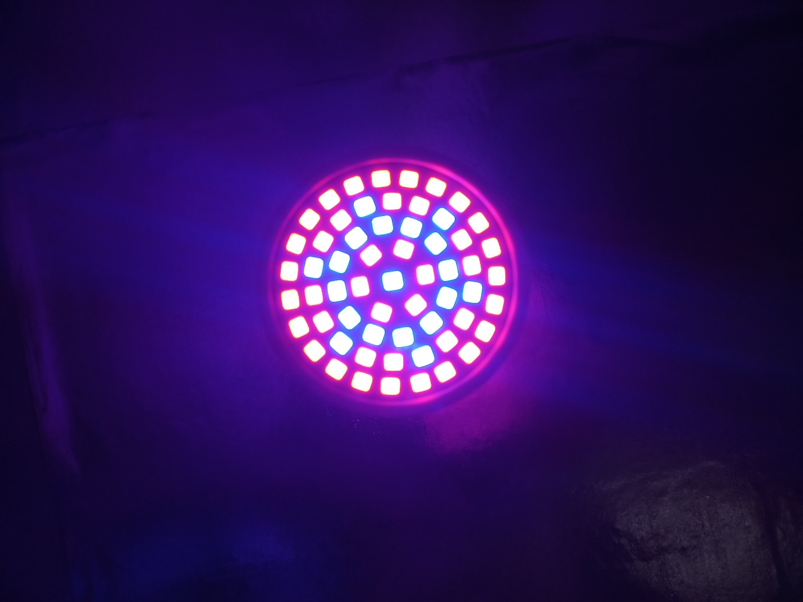

FIGURE 6.11 GROW LIGHT IS ON

As programmed if the temperature is above 25 degree Celsius the cooling fan is turned ON. The figure 6.12 shows the cooling fan turned ON.

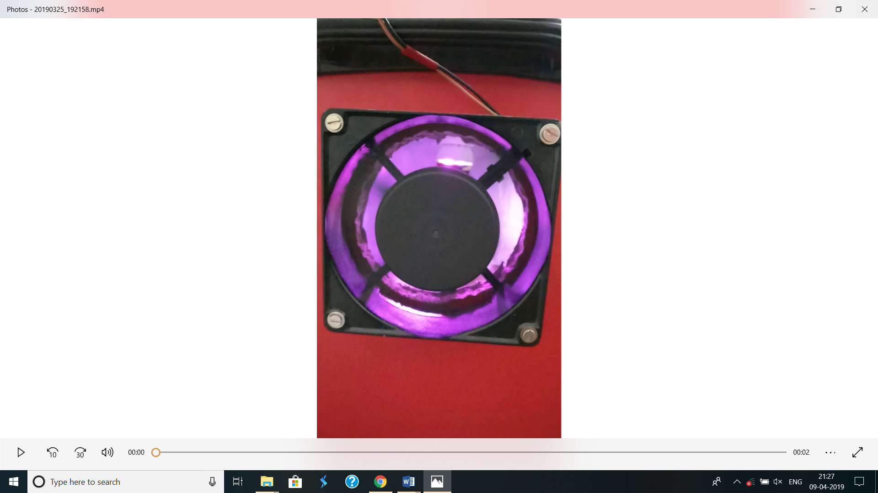

FIGURE 6.12 COOLING FAN IS ON

The plant is kept in the plant growing module such that the roots are dipped inside the solution. Figure 6.11 show how the plan the is kept inside the module. A small supporting cup with coconut fibre is used to hold the plant in the place.

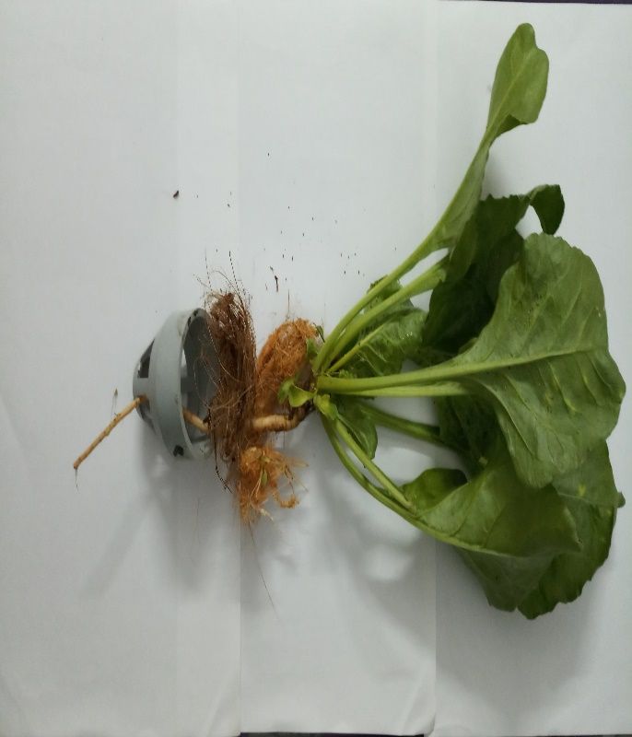

FIGURE 6.13 PLANT AND THE SUPPORTING CUP

Root

Holding cup

Coir

Plant

**CONCLUSION**

After knowing more about hydroponics, it is clear that it emerges as an more important type of agricultural technology in the world as it minimizes the use of limited land space. Although the cost of setting up is high, future of agriculture industry lies with high technology farming and also believe that that crops produced is enough to sustain population in a few more years without the help of external food imports.

Hydroponics systems give more control to the farmer and desire much less maintenance then the average garden. With a hydroponics system, farmers no longer have to worry about how contaminated their soil is, or if their soil has enough nutrients. Farmers and gardeners would no longer have to worry about getting the plants watered on time or where to fit all of them. Hydroponics systems give the user more control over their gardens because it controls which nutrients are received by adding them directly to the systems water supply. There is also no soil involved in hydroponic gardening, which means there is no soil to potentially contaminate plants, and all these benefits take place in an area much smaller than what would be needed for a soil garden because the roots of plants do not have to spread out two feet and so it can be planted everything much closer together.  
 Hydroponics gardening systems have the potential to benefit the whole world, from the urban farmers who do not have the space or time to maintain a healthy garden or the poverty stricken individuals who do not have an abundance of resources to work with.  Hydroponics systems have the potential to benefit the rest of the world because of the limited resources it uses and the high yield rate which can entail a consistent and time efficient way to make money for individuals in more poverty stricken countries. With worlds resources becoming increasingly limited as the population is growing, the time is now to convert to hydroponics gardening to help conserve resources for future community and the rest of the world.  
 As the environment continues to be heavily affected by our actions, it is time to change the ways. When there is an opportunity to save our time and resources right in front , we have to be environmentally conscious when its possible. The benefits of hydroponic gardening outweighs current systems by creating a low maintenance and high yield system. These benefits can be utilized all around the world and are very adaptable depending on circumstance andlocation.

**BIBLIOGRAPHY**

1. <https://home.howstuffworks.com/lawn-garden/professional-landscaping/hydroponics.htm>
2. <https://www.fullbloomhydroponics.net/hydroponic-systems-101/>
3. <https://www.greenandvibrant.com/advantages-disadvantages-of-hydroponics>
4. <https://www.maximumyield.com/definition/70/hydroponics>
5. <http://www.simplyhydro.com/whatis.htm>
6. <https://homeguides.sfgate.com/grow-lettuce-using-hydroponics-69112.html>
7. <https://www.farmhydroponics.com/hydroponics/hydroponic-lettuce>
8. <https://www.theengineeringprojects.com/2018/08/introduction-to-pic16f887.html>